For Qustions from 0-10 : Code contain how to print ,if- ifels statement , and addition ,subtraction and division,mod,power, for loop , call functions, change integer to string ,add to the string,2d list , nested for loop,convert map to list,sort 2d list to get maximum .

For Questions from 11-20:code contain how to print float with 2decimal point, bulidin function of list “ insert, reverse,pop,print,remove,append,sort,remove”,tuple ,switch leteer cases of string ,split string and join the list with character like “-”,how to print string, string is immutable so we changed to list to be mutable, return first index of the string that contain substring, use bulidin function of string like” isalnum() , isalpha(), isdigit(),islower(),isupper(),center(),jleft(),rjust().

For Questions from 21-30:code contain how to bulidin function textwerp to cut string for substrings by size, Designer Door Mat,String Formatting,Alphabet Rangoli,how to caplize string contain more than one word by capitalize(),The Minion Game, splite string then remove repletion of each subset, create tuple and print at same line use end=” ” in print function,collections.Counter() ,use permutations(),Polar Coordinates, get average of distance list, DefaultDict Tutorial, get day from A single line of input containing the space separated month, day and year, respectively,code in try-catch to handle exptions, Collections.namedtuple(),get absolute different of 2 datetamp,

1. Say "Hello, World!" With Python

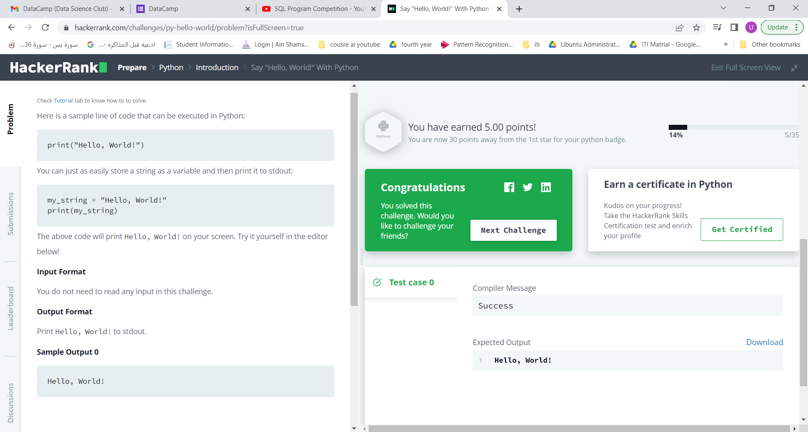

1. Python If-Else

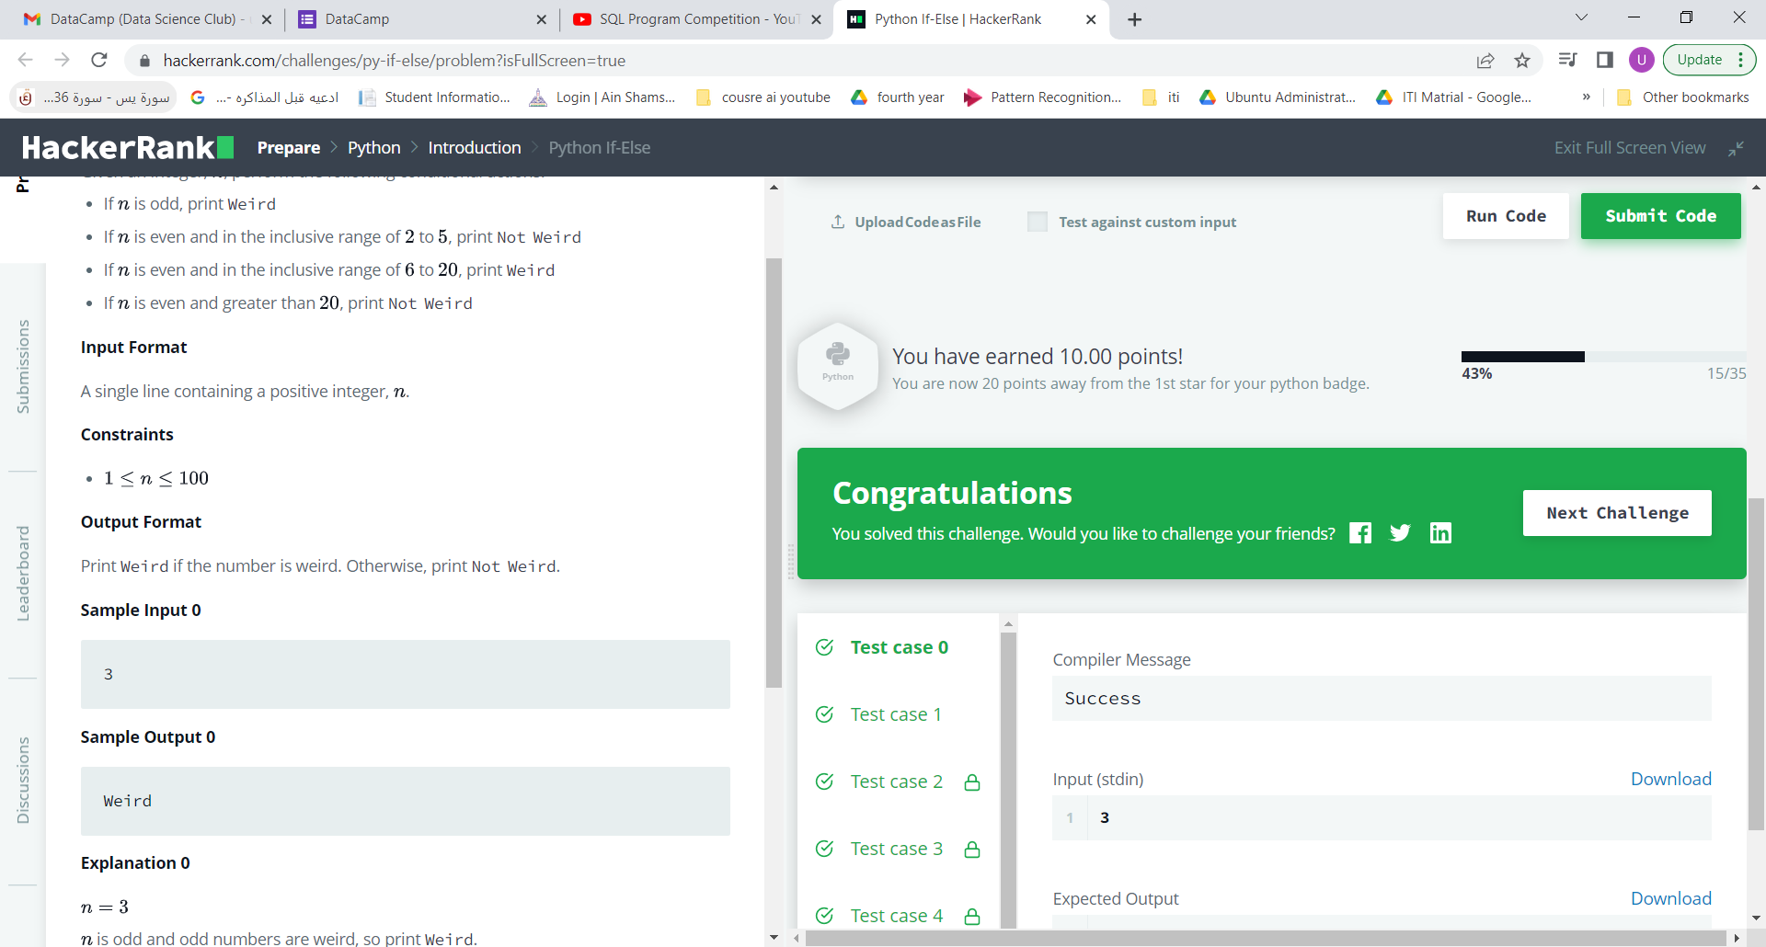

1. Arithmetic Operators

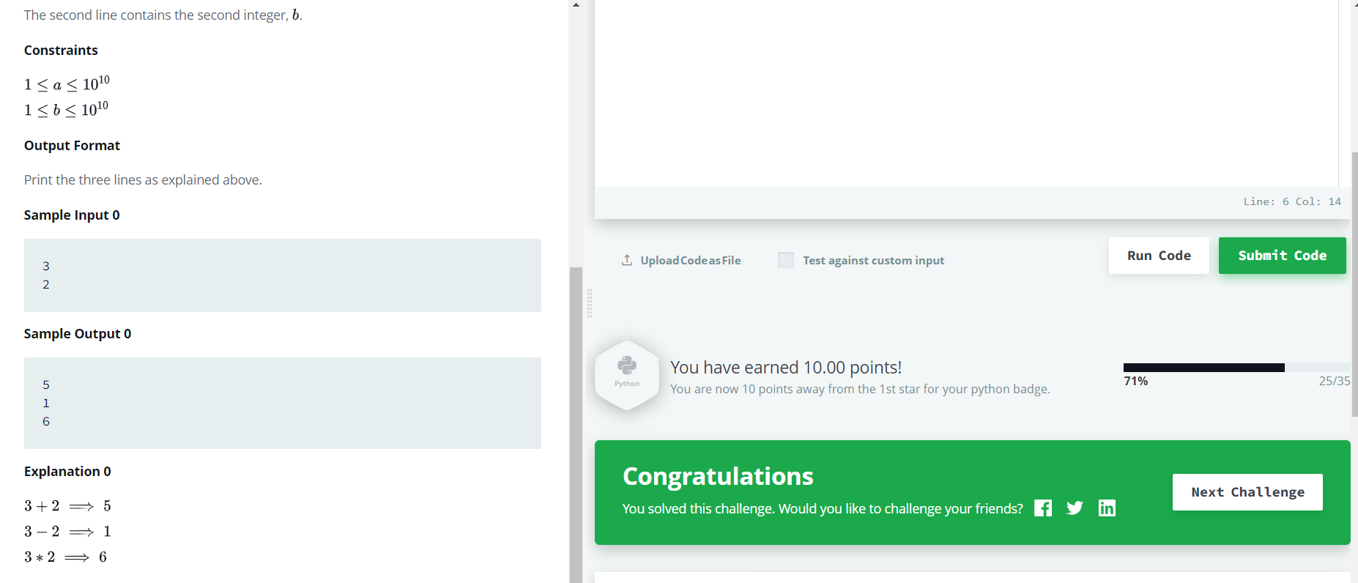

1. Python: Division

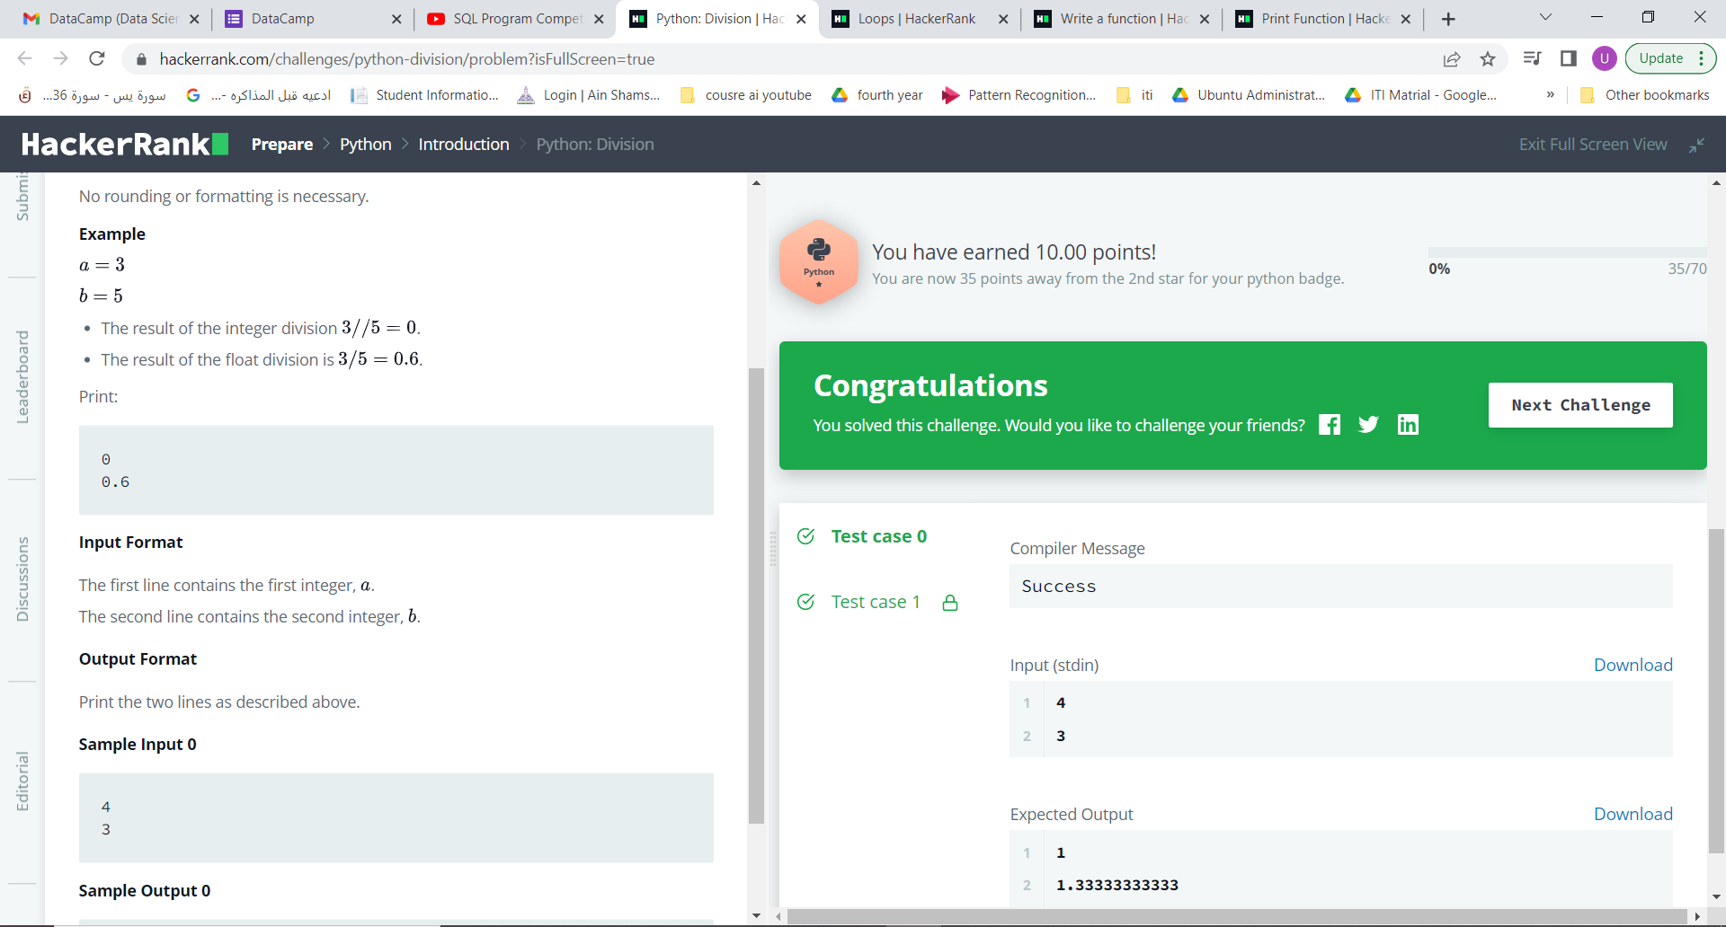

1. Loops

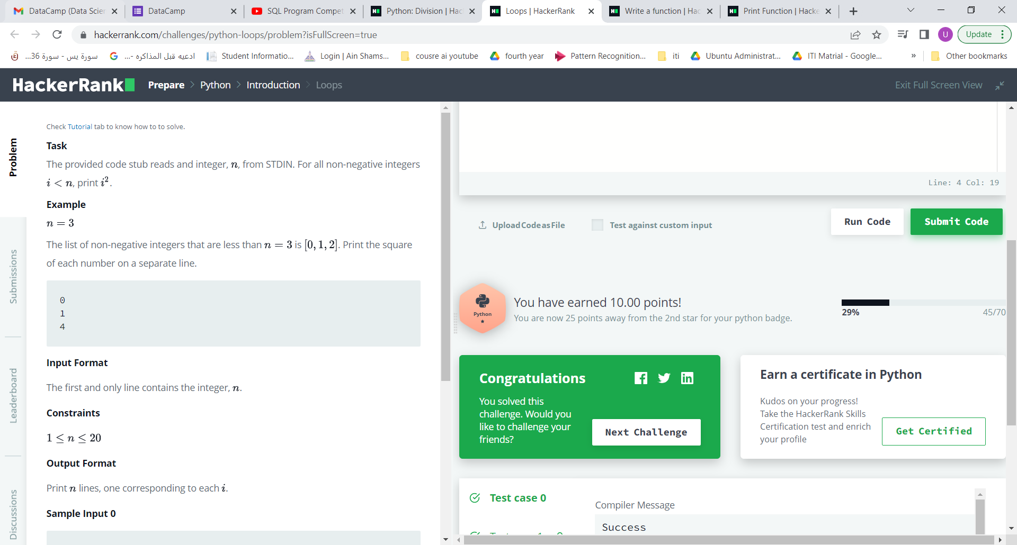

1. Write a function

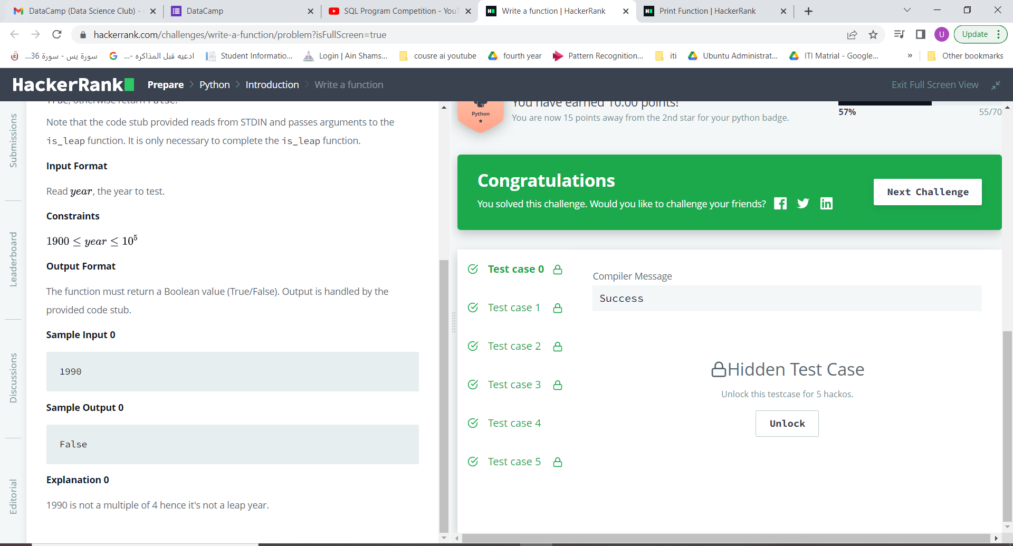

1. Print Function

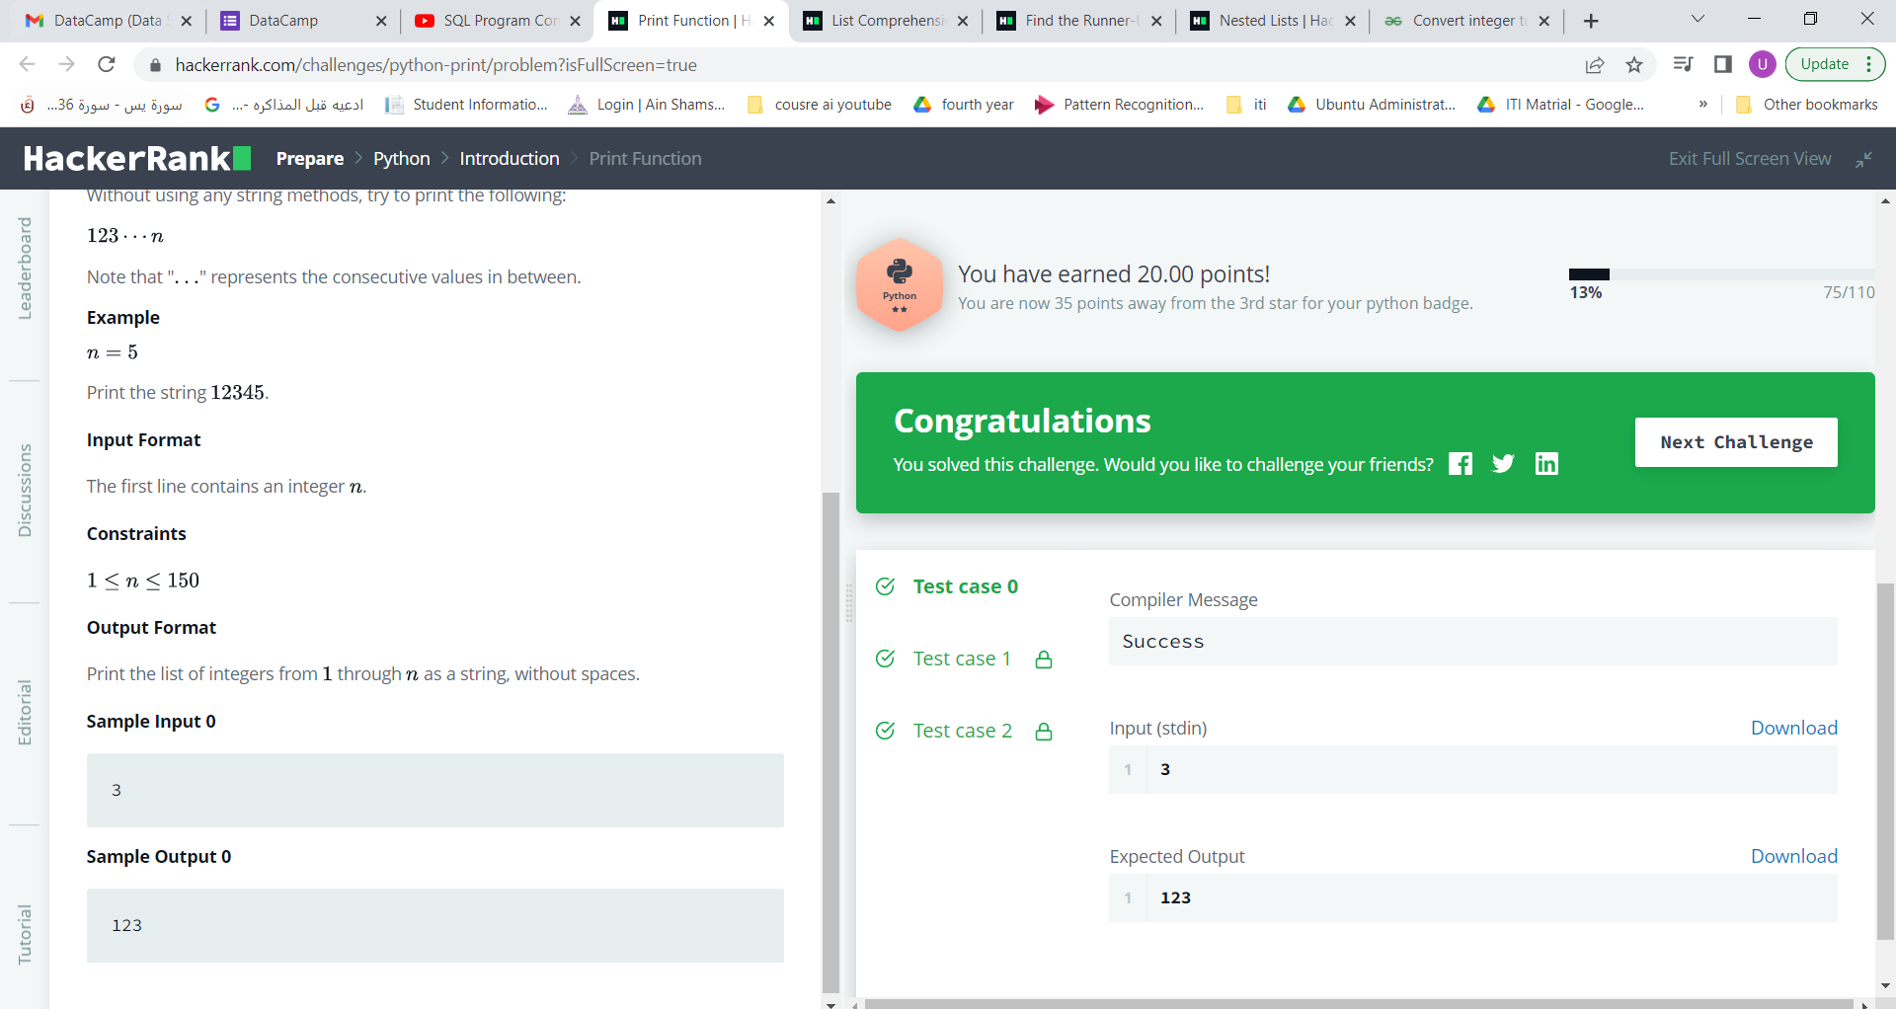

1. List Comprehensions

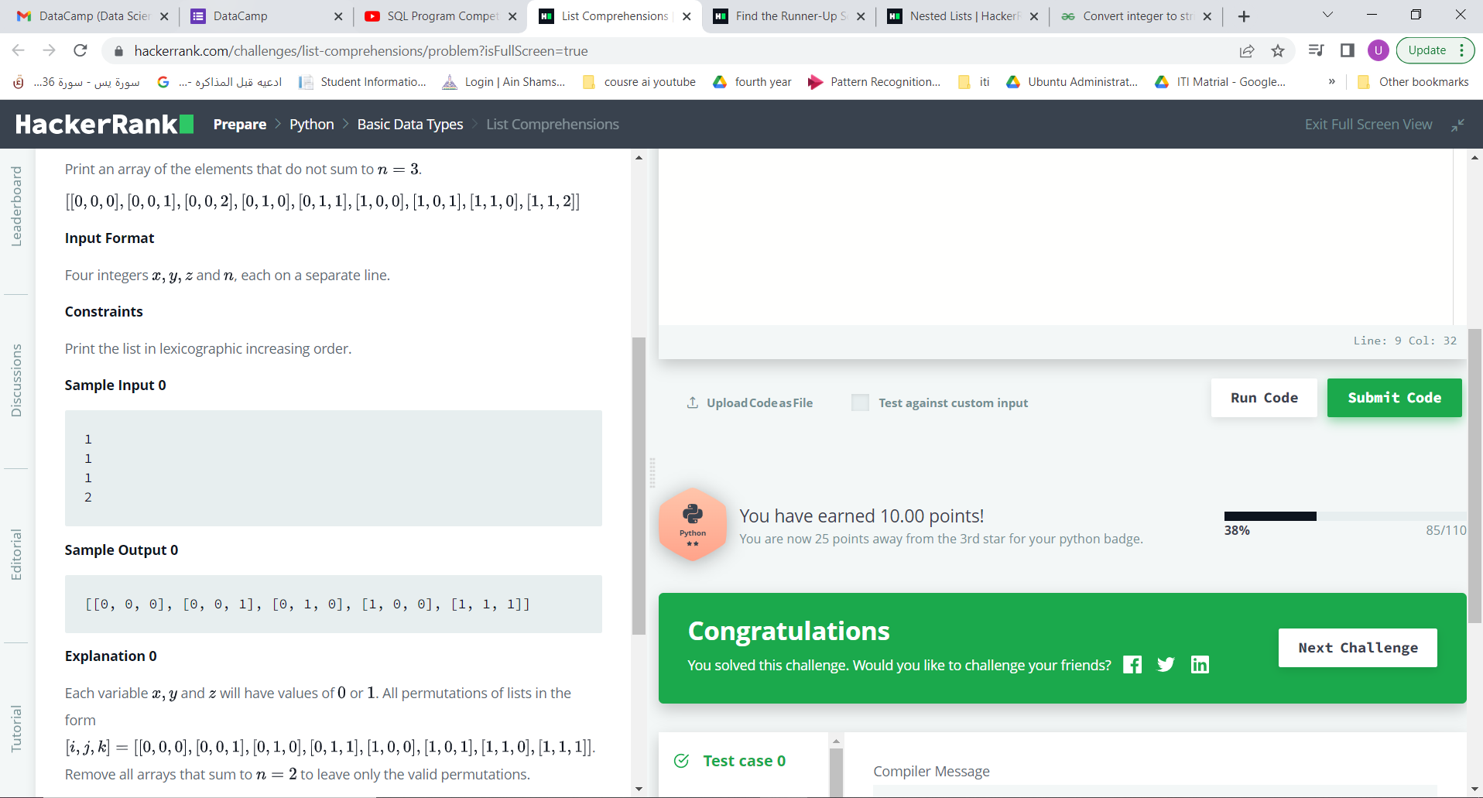

1. Find the Runner-Up Score!

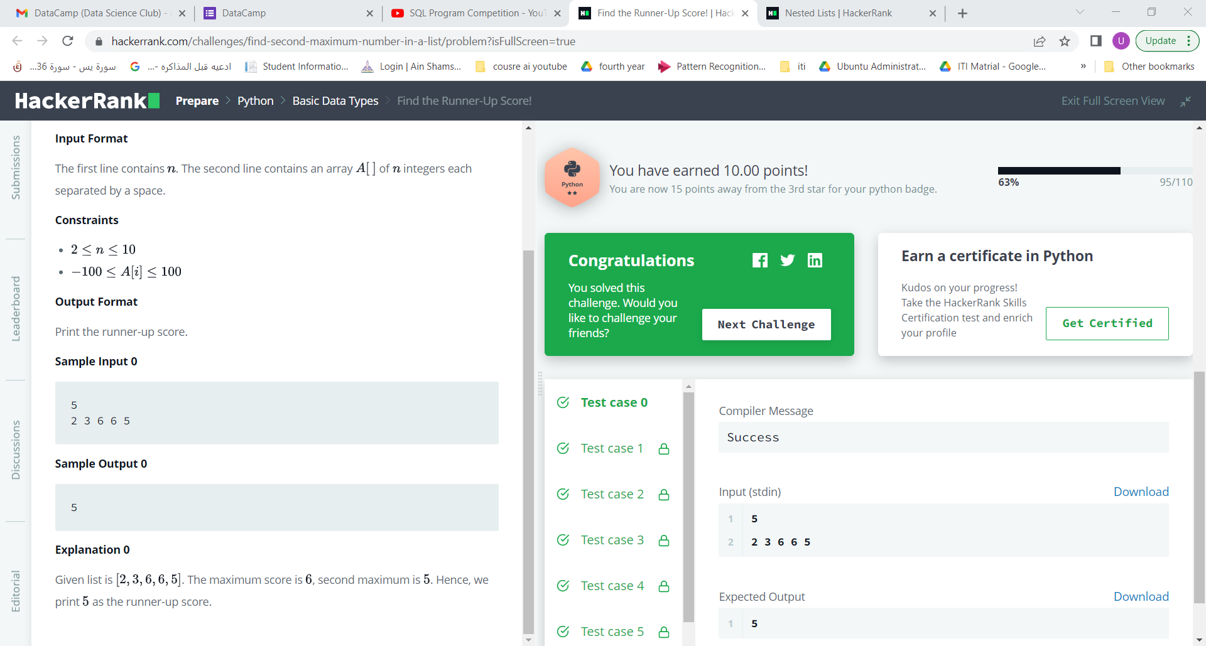

1. Nested Lists

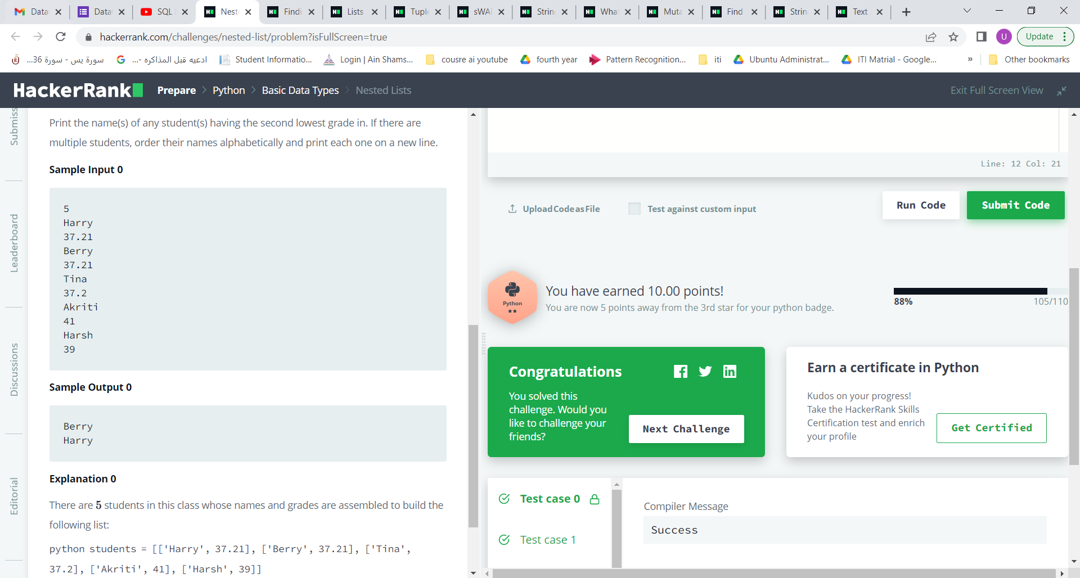

1. Finding the percentage

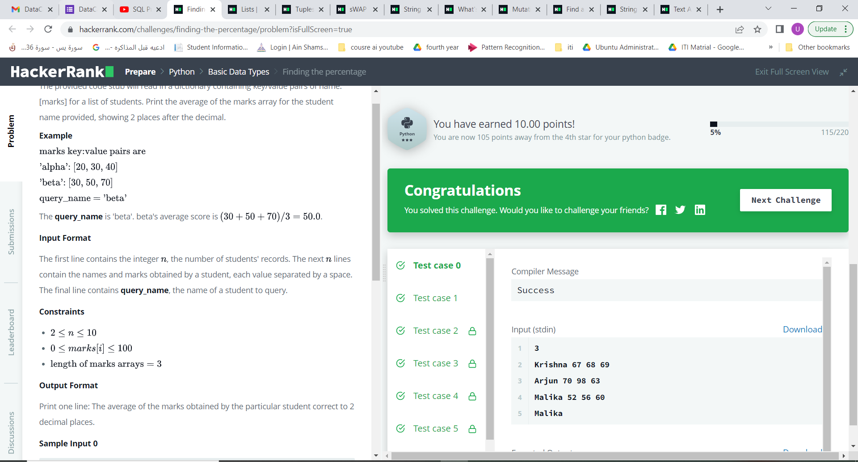

1. Lists

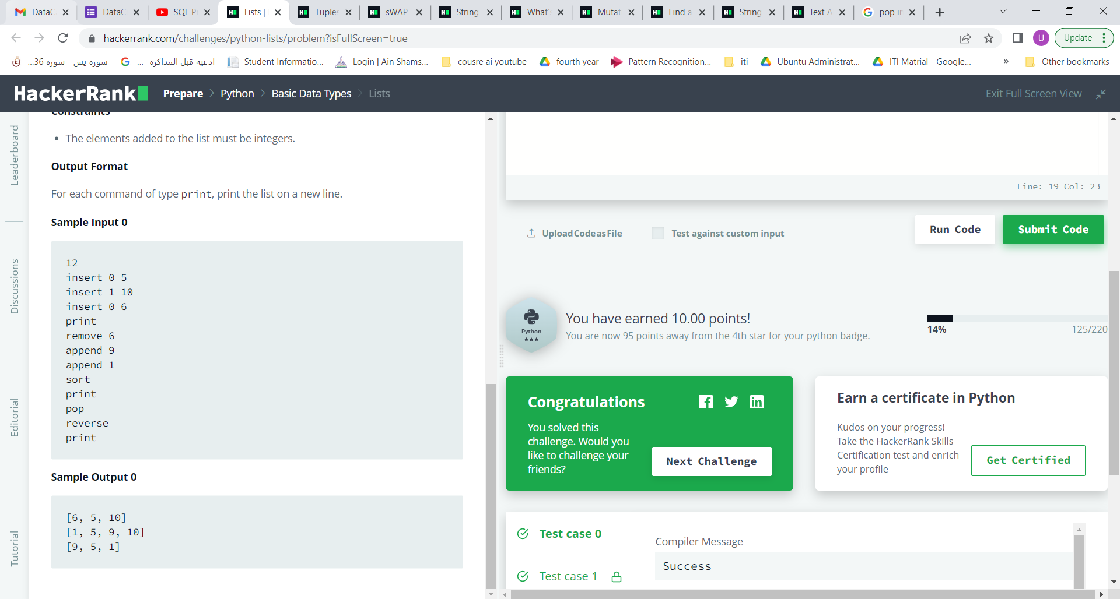

1. Tuples

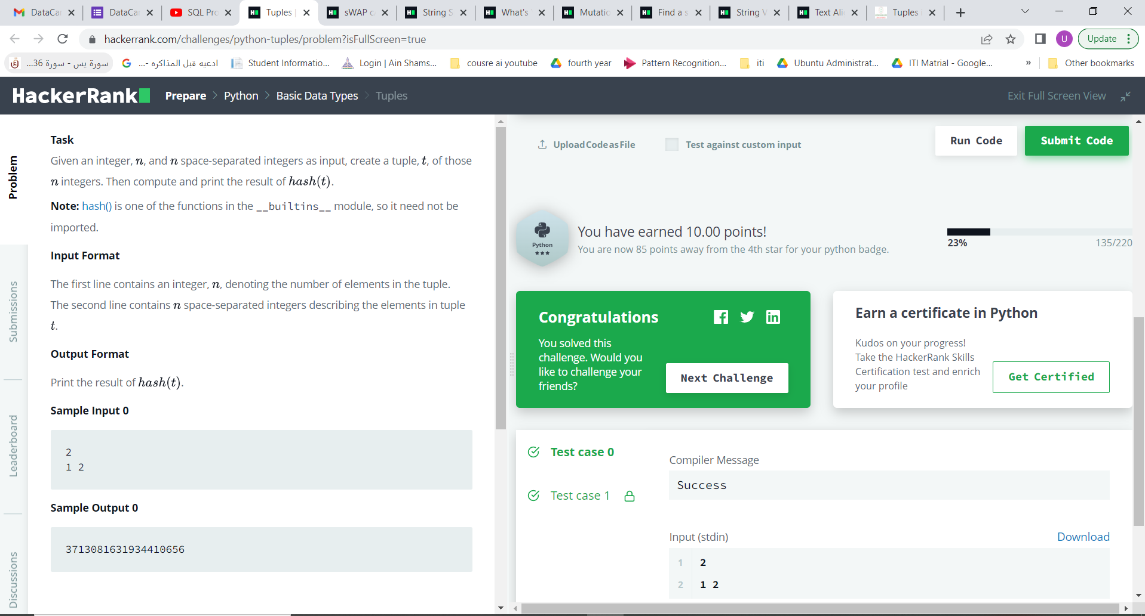

1. sWAP cASE

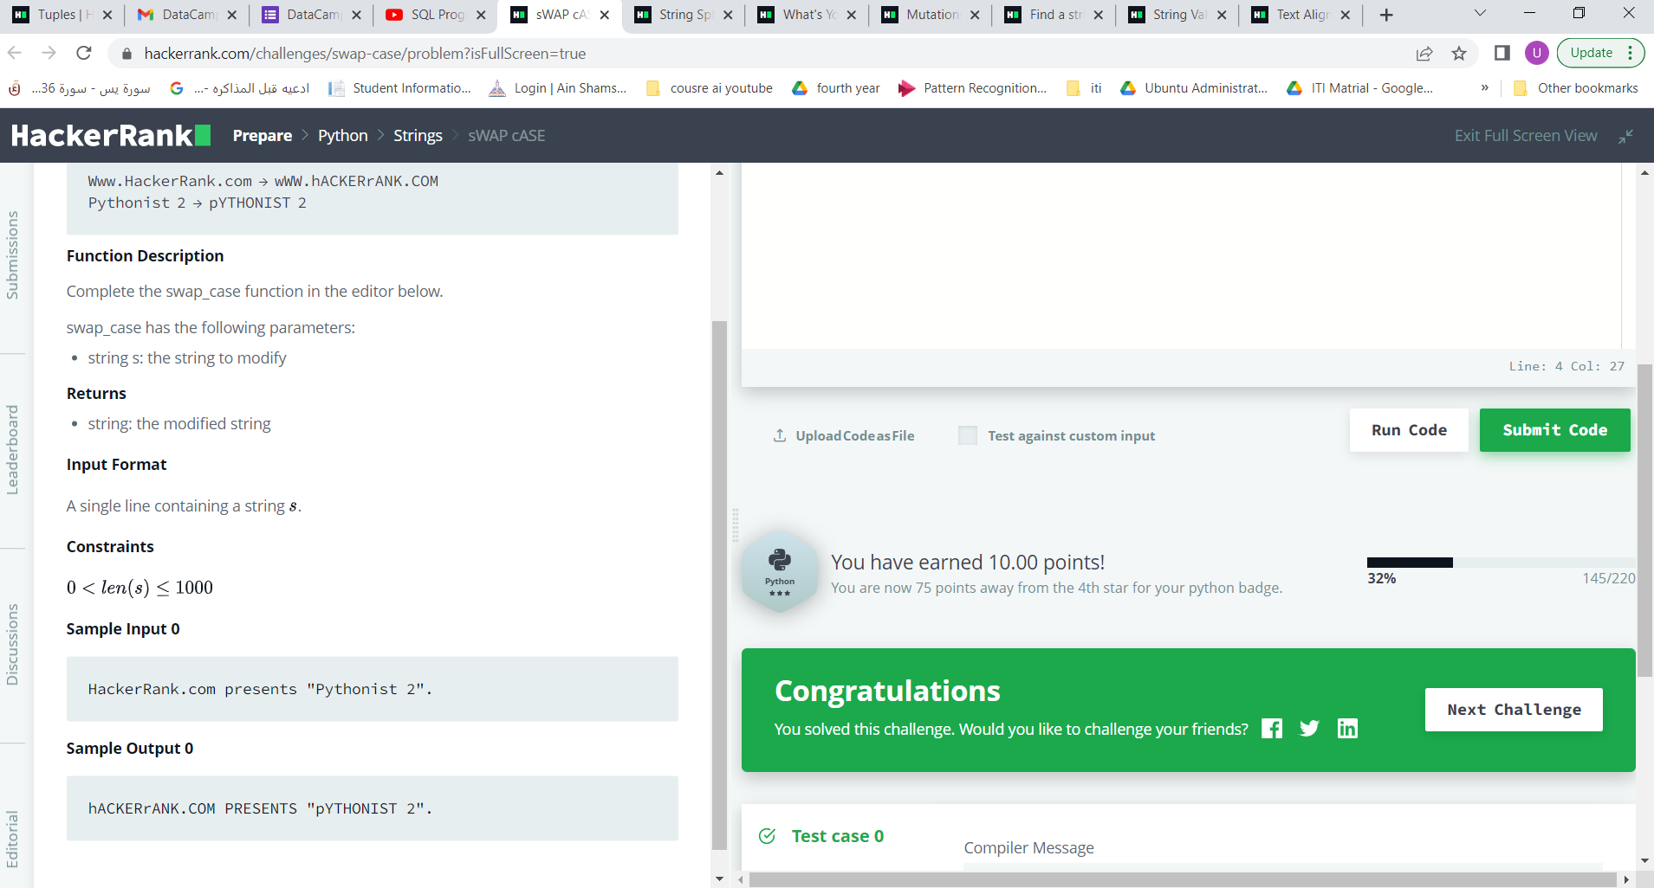

1. String Split and Join

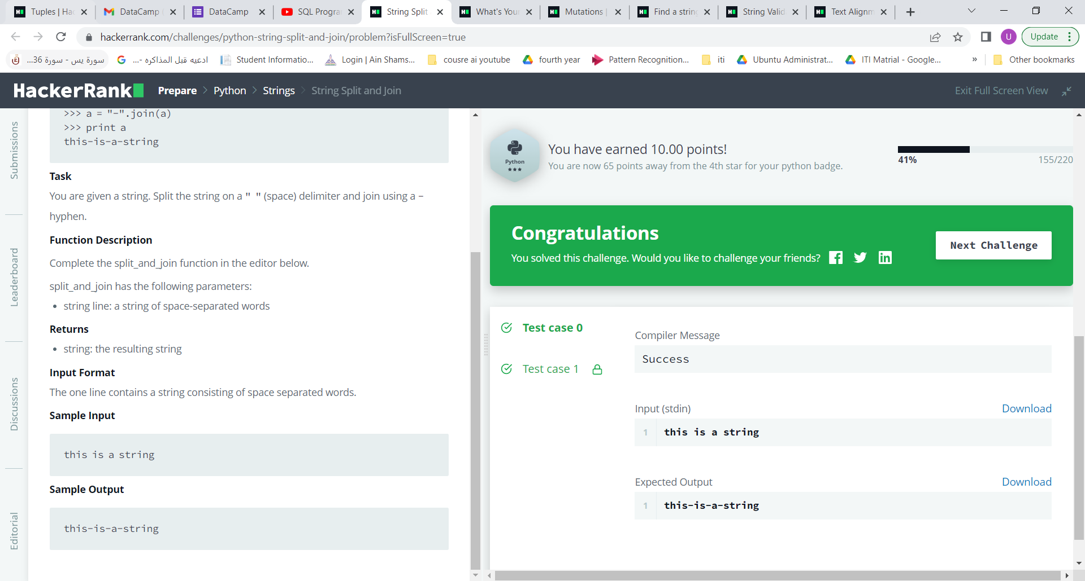

1. What's Your Name?

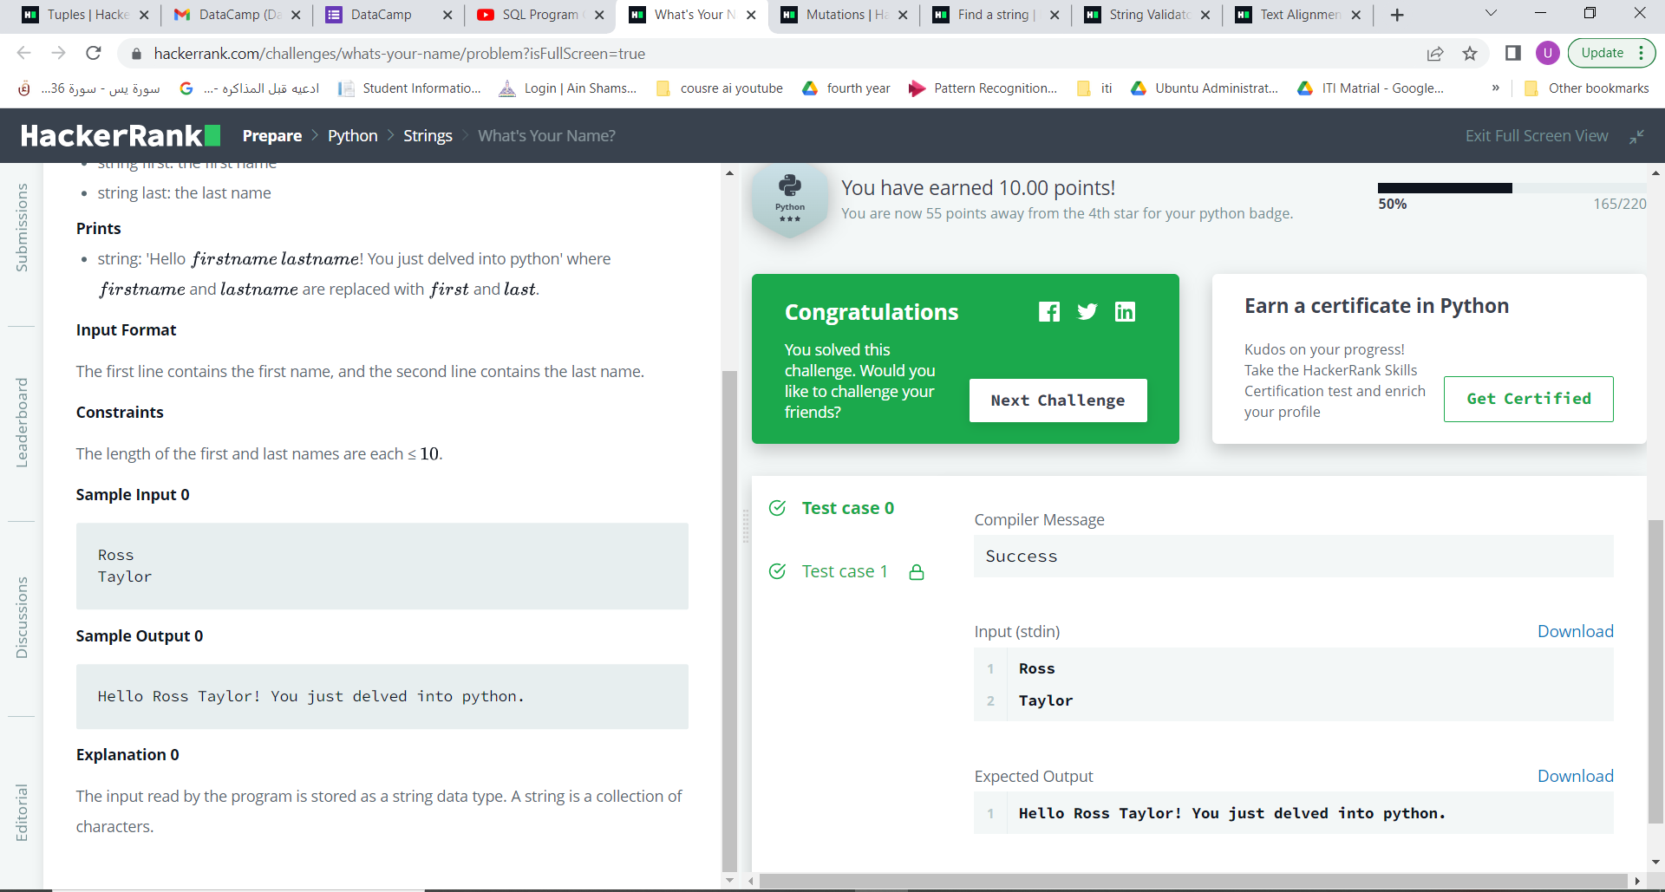

1. Mutations

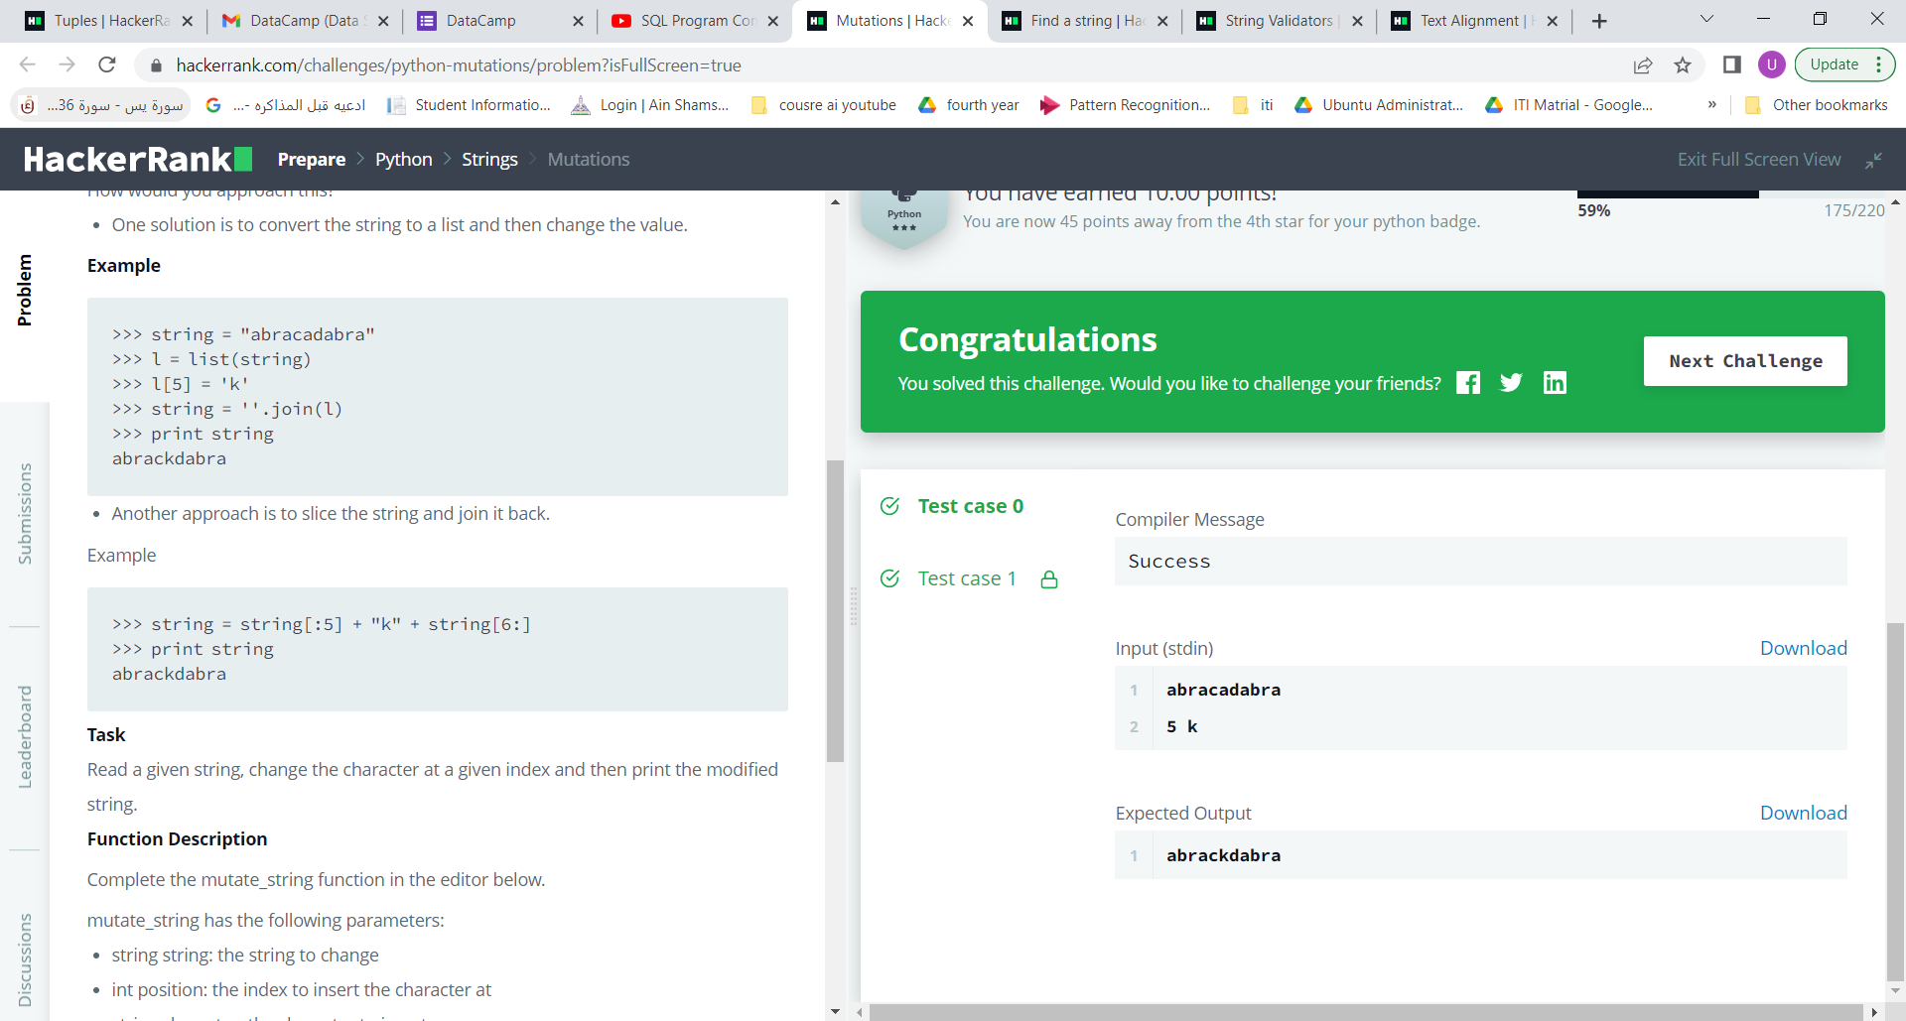

1. Find a string

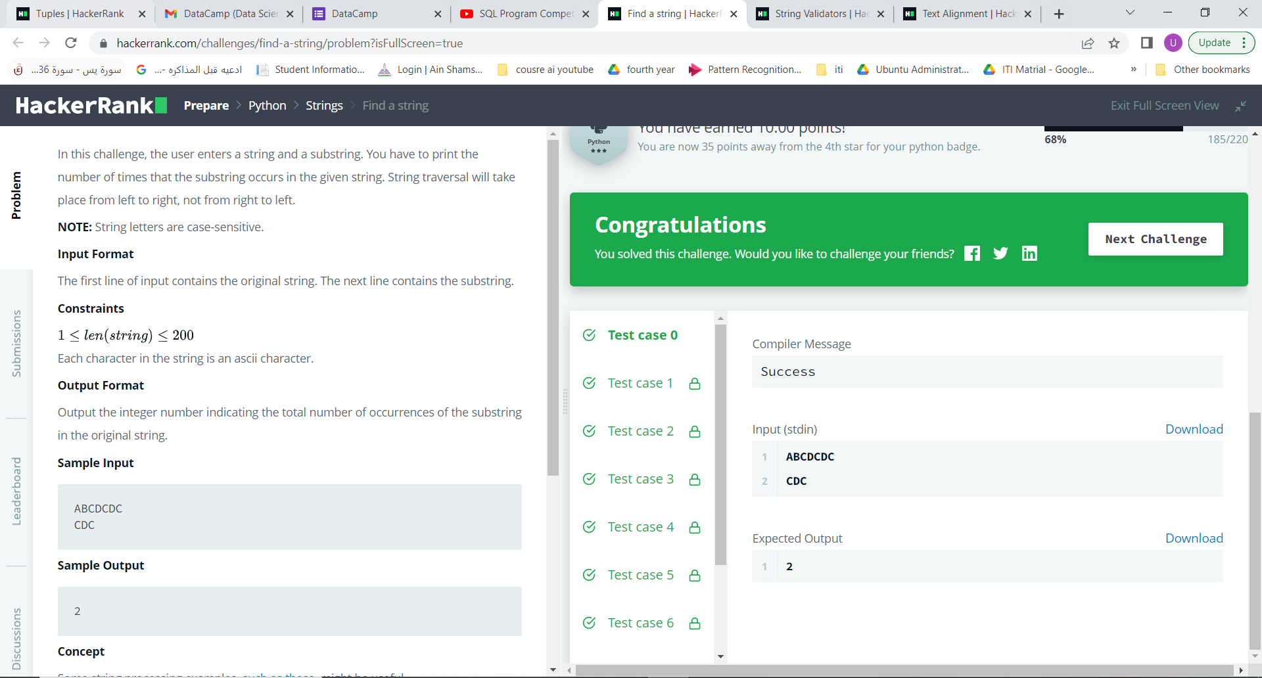

1. String Validators

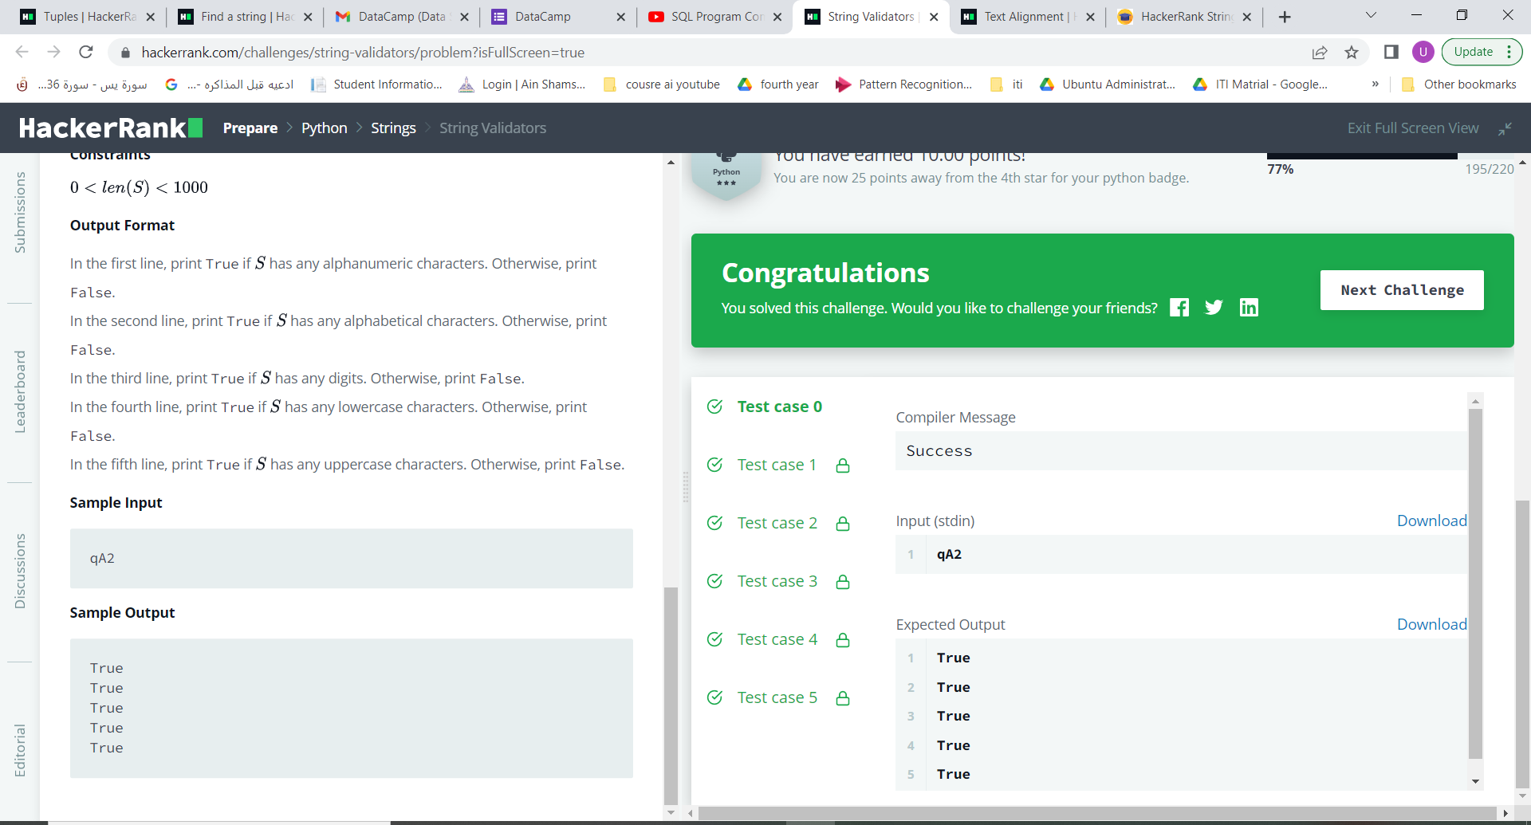

1. Text Alignment

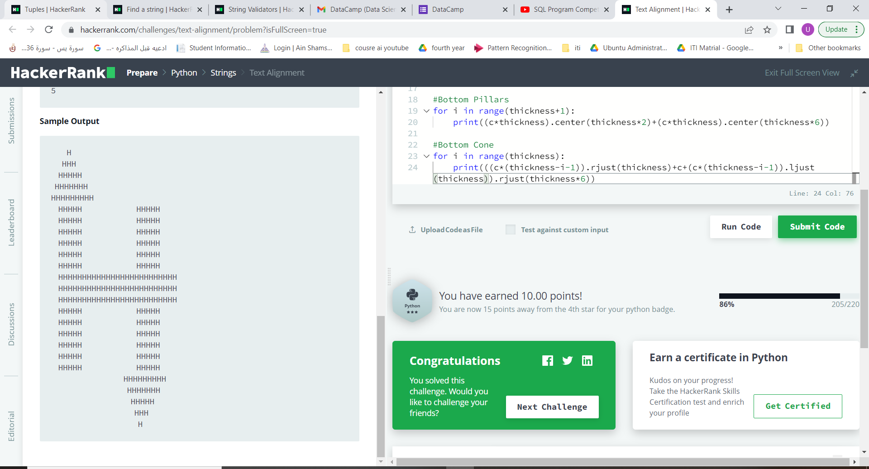

1. Text Wrap

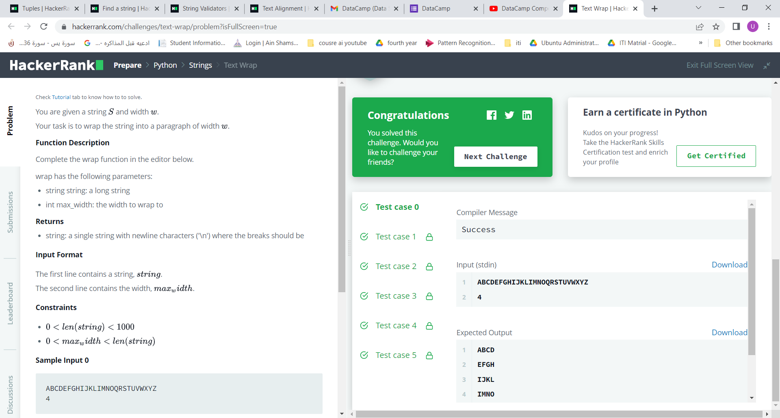

1. Designer Door Mat
2. String Formatting
3. Alphabet Rangoli
4. Capitalize!

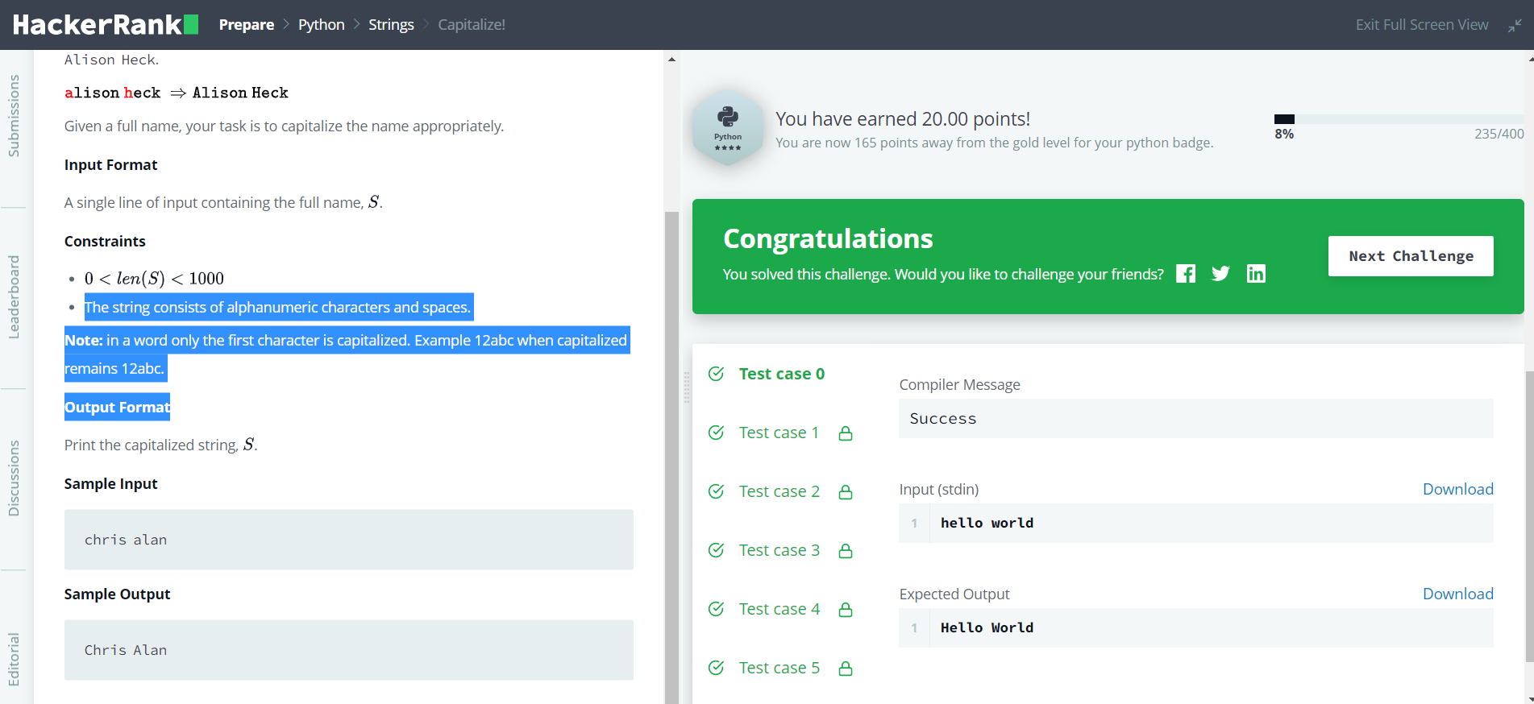

1. The Minion Game
2. Merge the Tools!

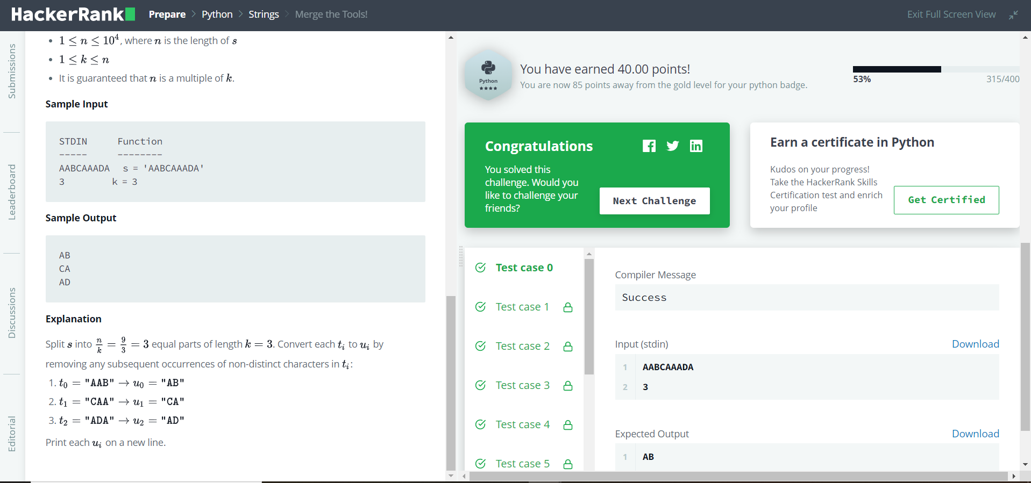

1. itertools.product()

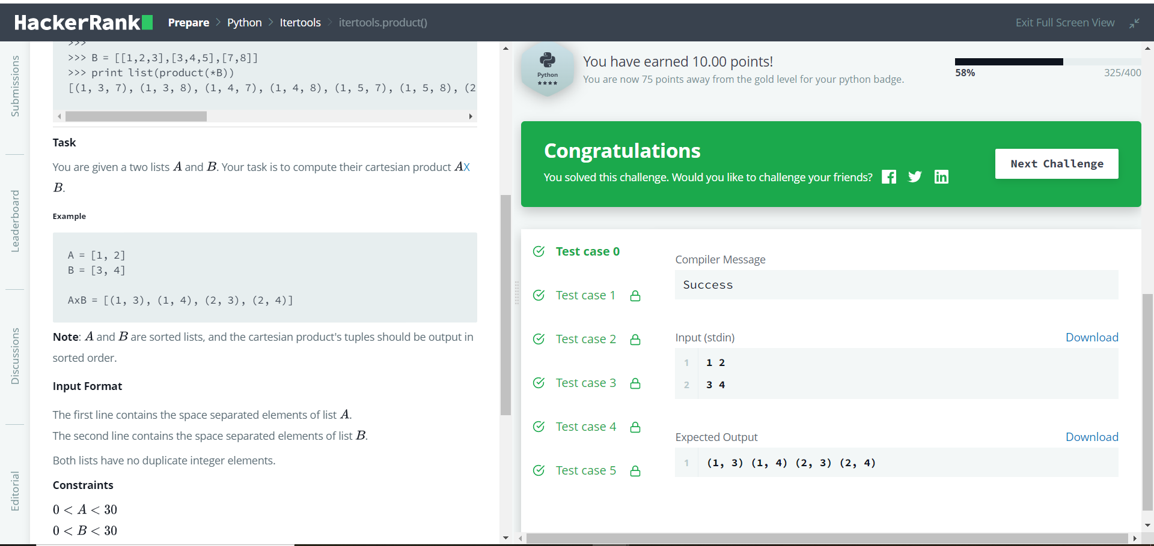

1. collections.Counter()
2. itertools.permutations()

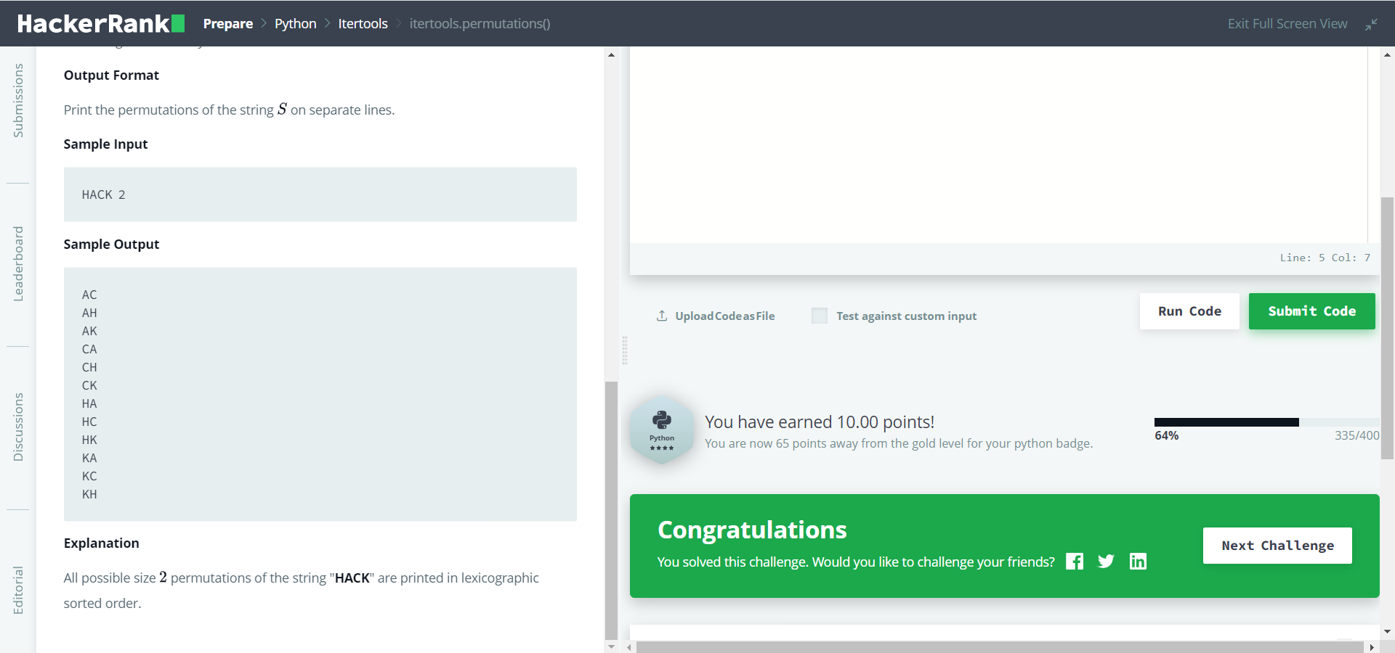

1. Polar Coordinates
2. Introduction to Sets

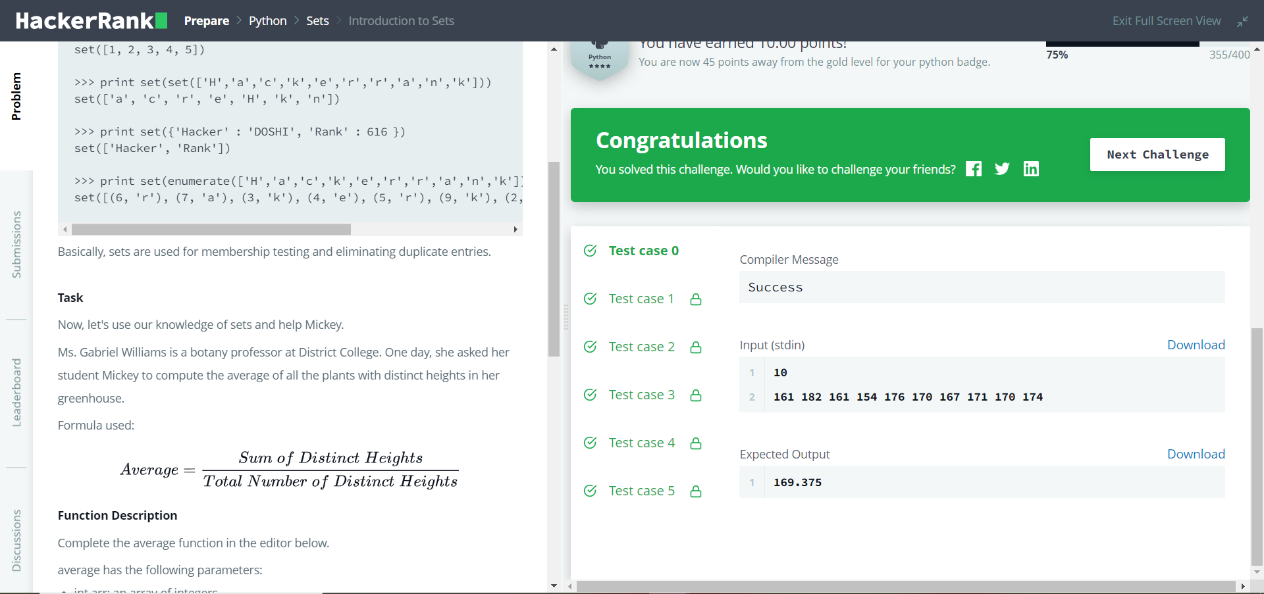

1. DefaultDict Tutorial
2. Calendar Module

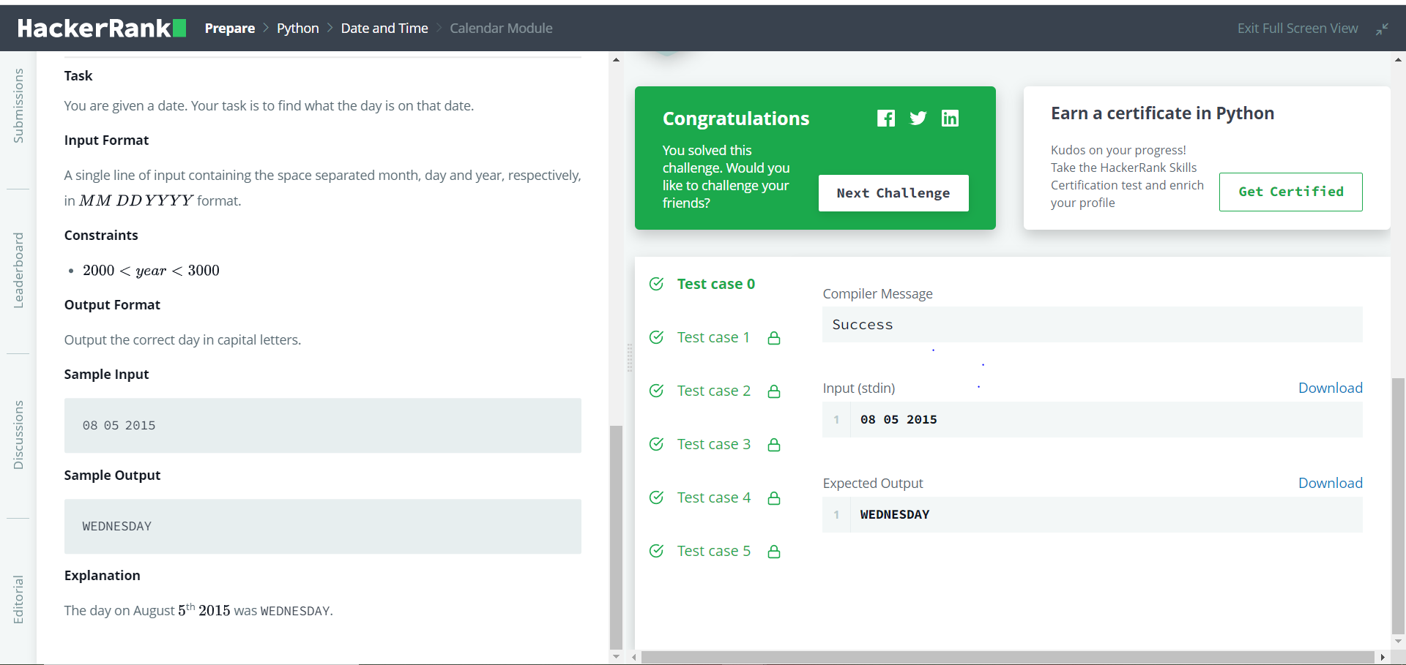

1. Exceptions



1. Collections.namedtuple()
2. Time Delta

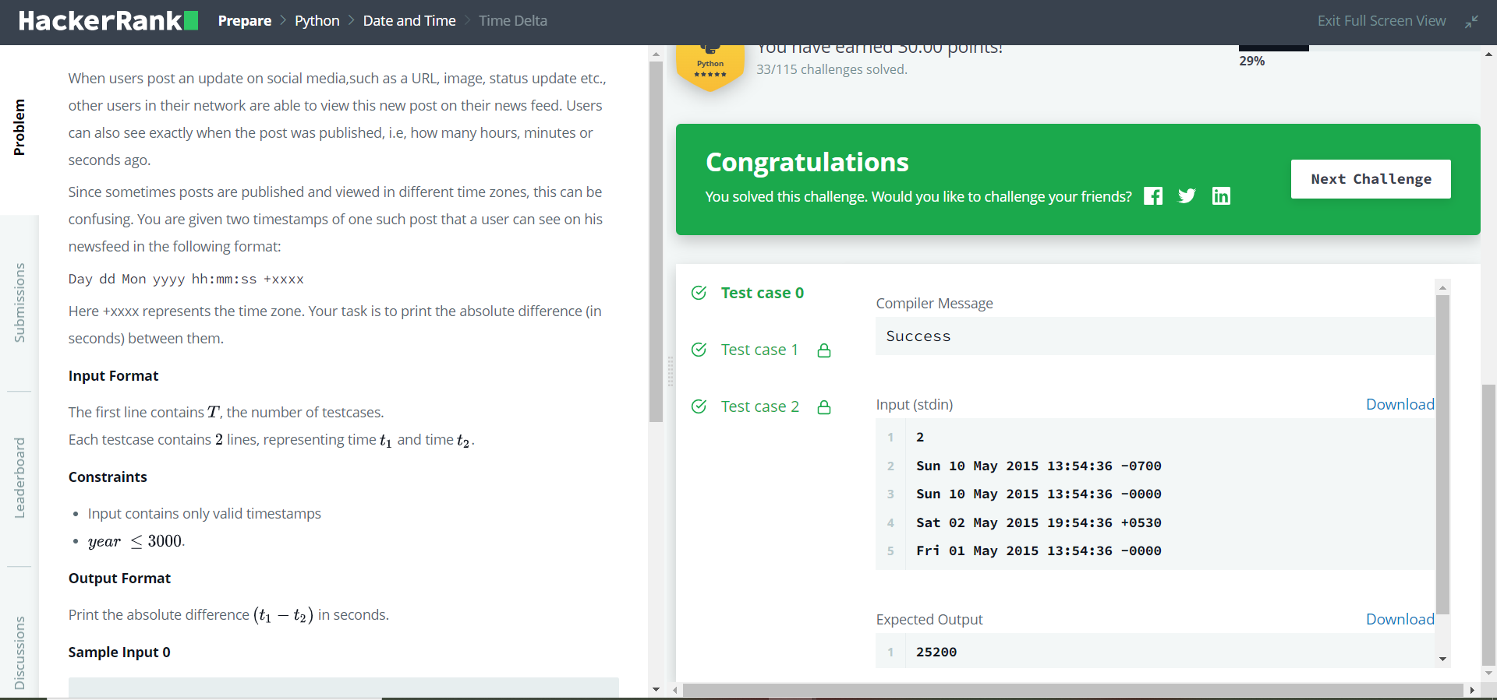

1. Find Angle MBC
2. No Idea!
3. Collections.OrderedDict()

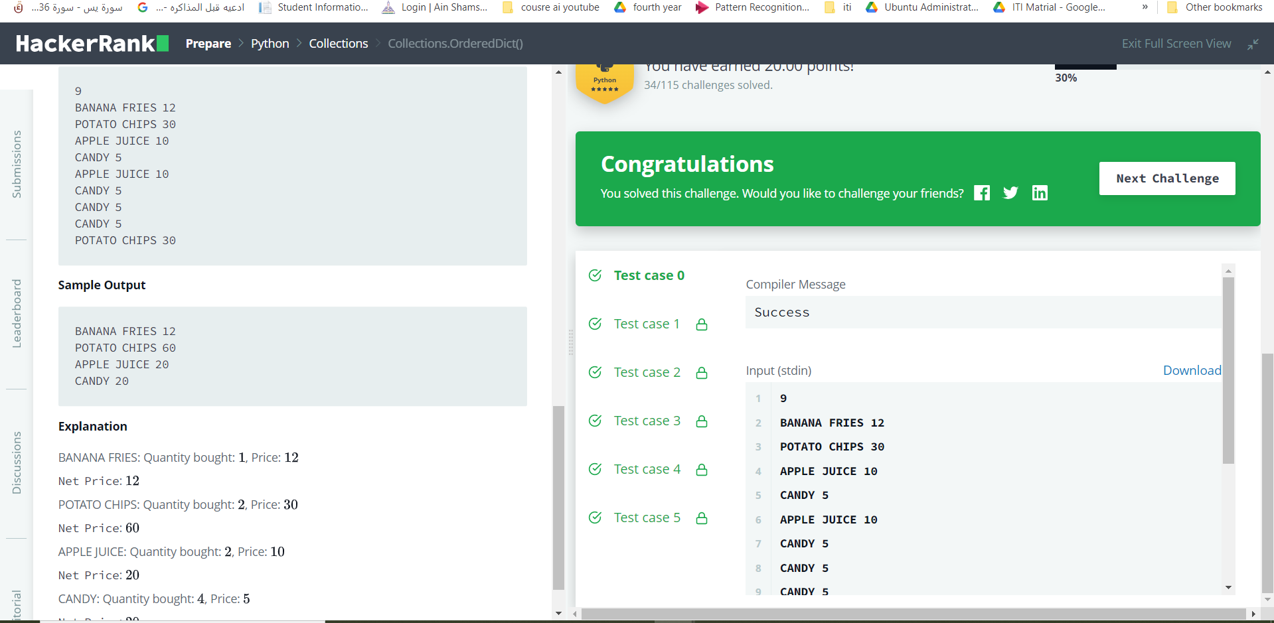

1. Symmetric Difference

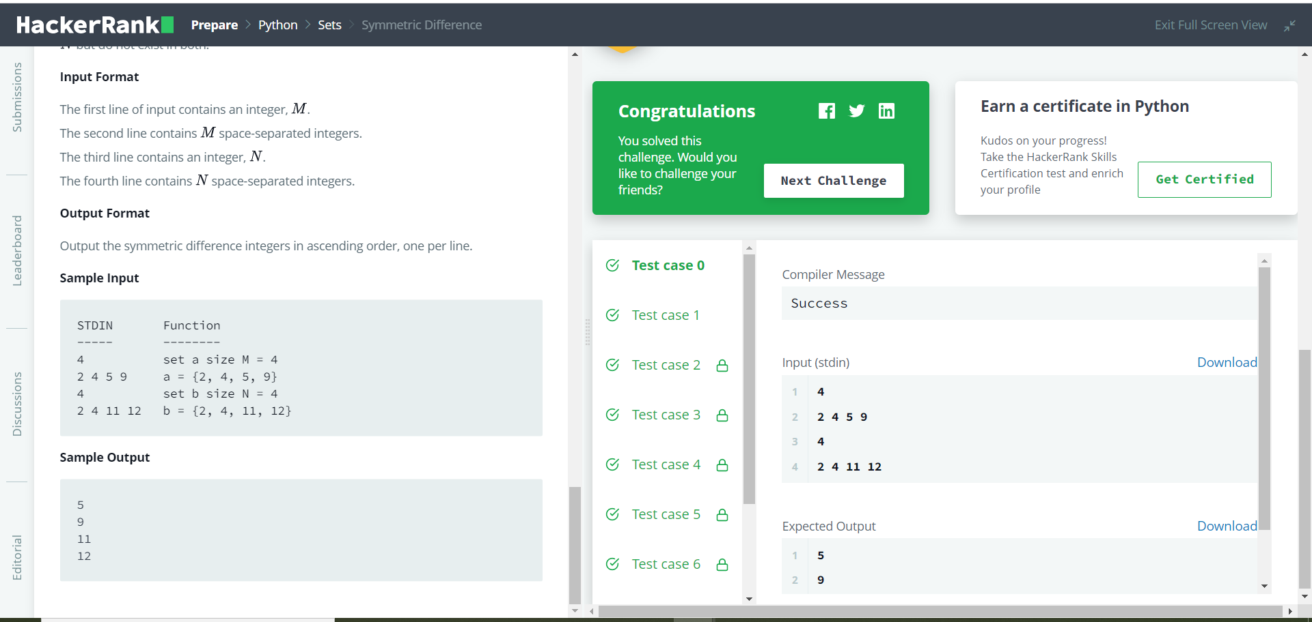

1. itertools.combinations()

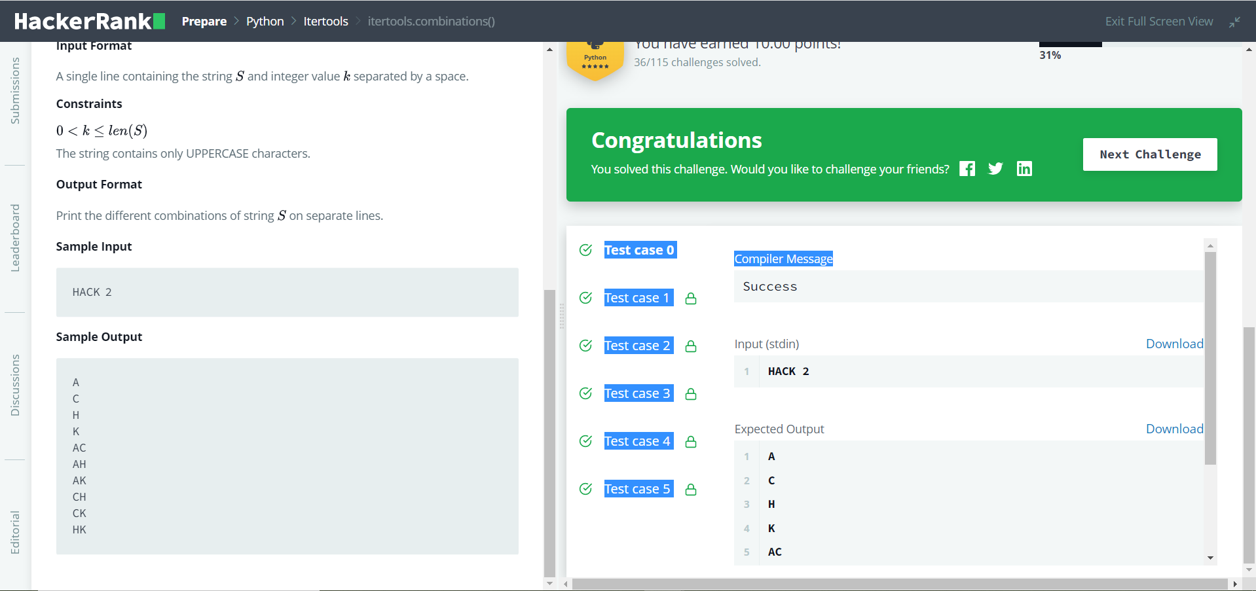

1. Incorrect Regex

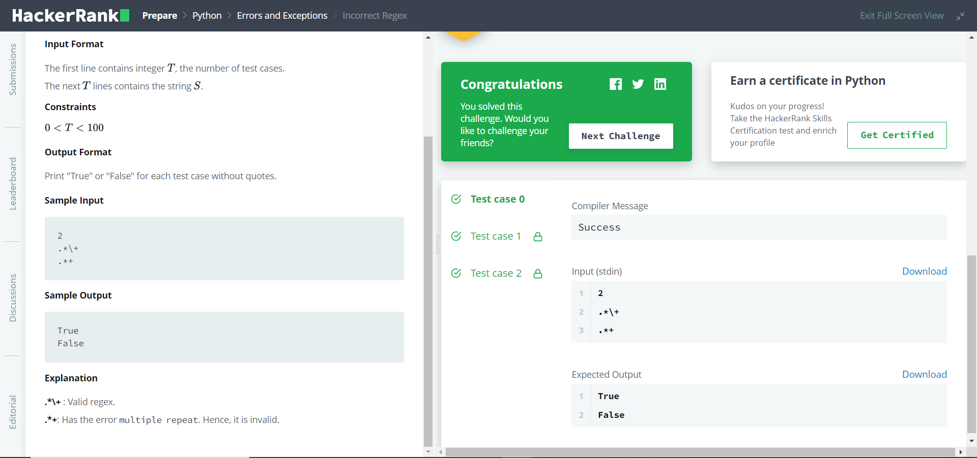

1. Set .add()

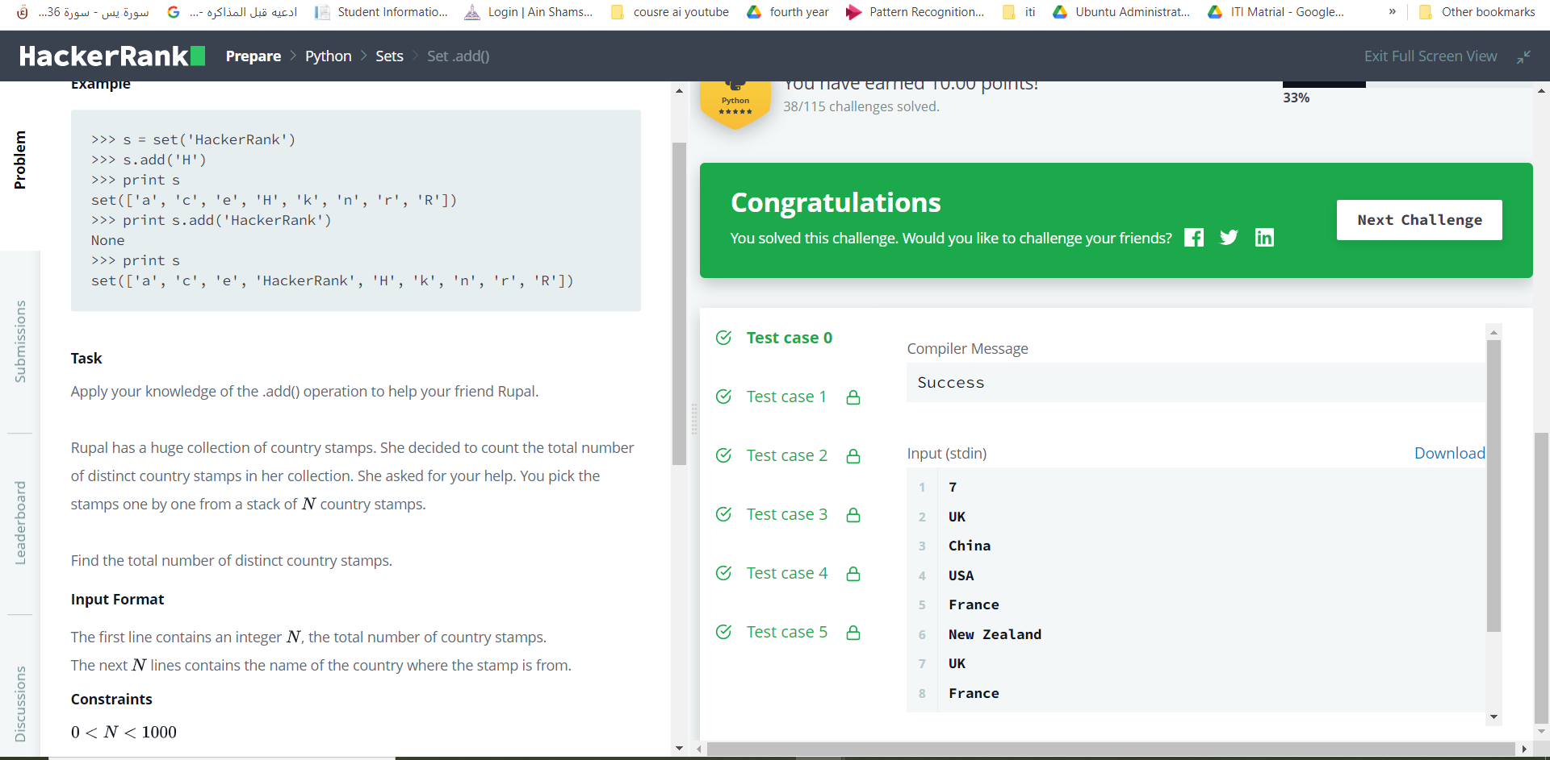

1. itertools.combinations_with_replacement()

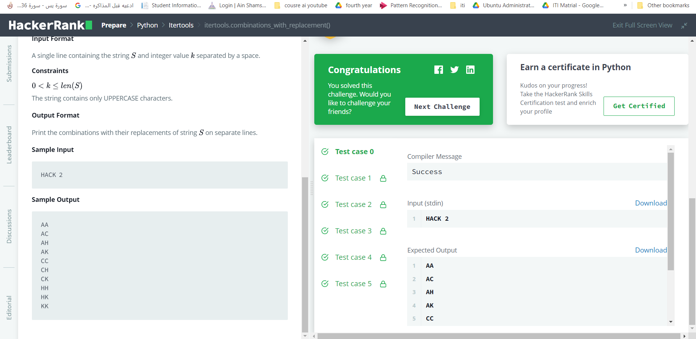

1. Word Order

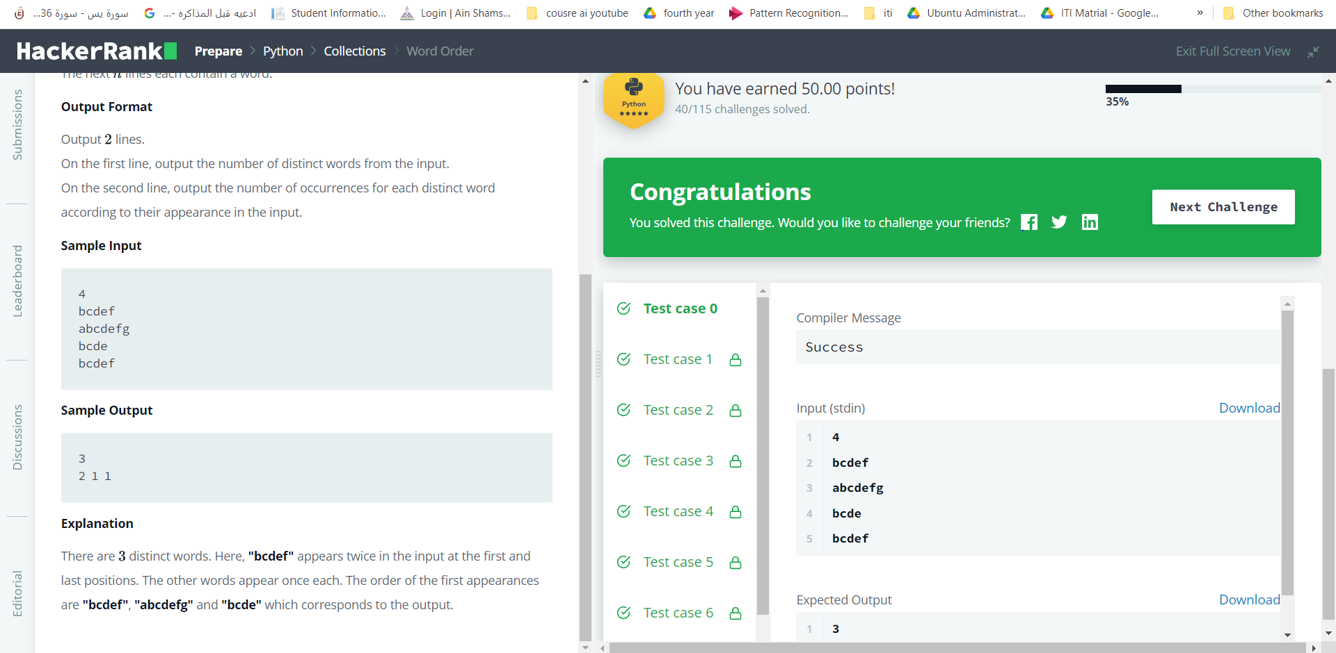

1. Set .discard(), .remove() & .pop()

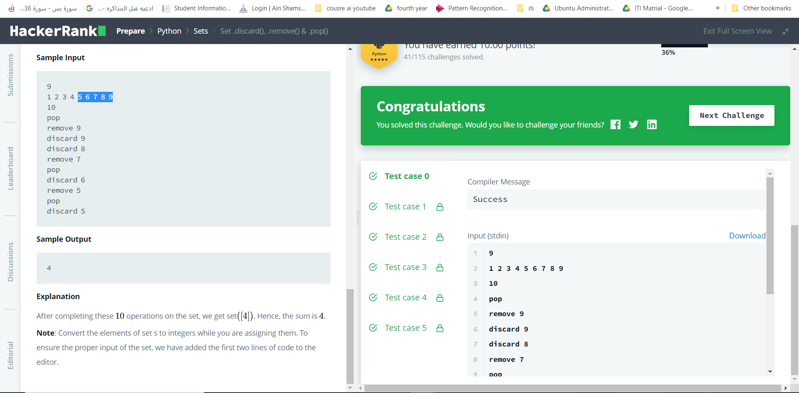

1. Collections.deque()
2. Compress the String!

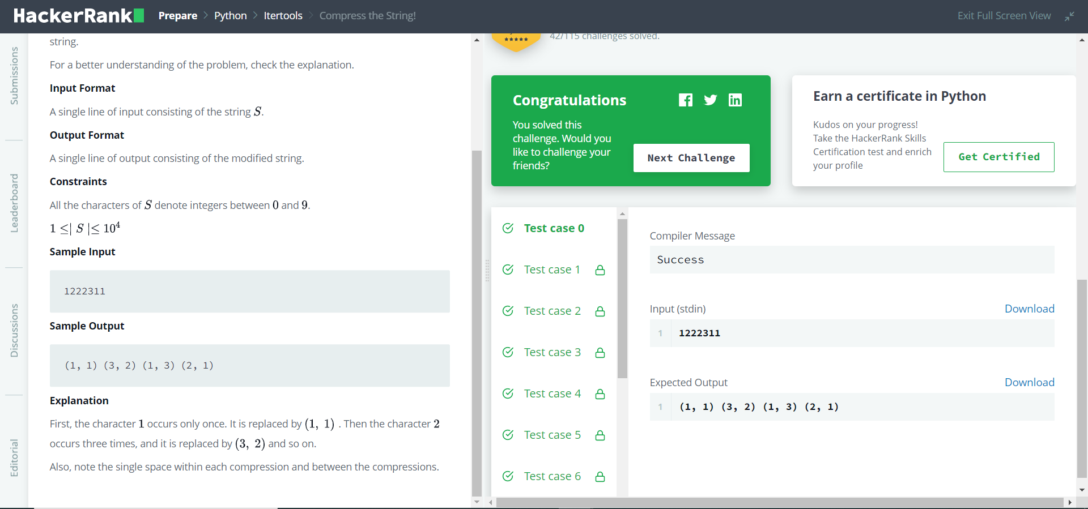

1. Company Logo

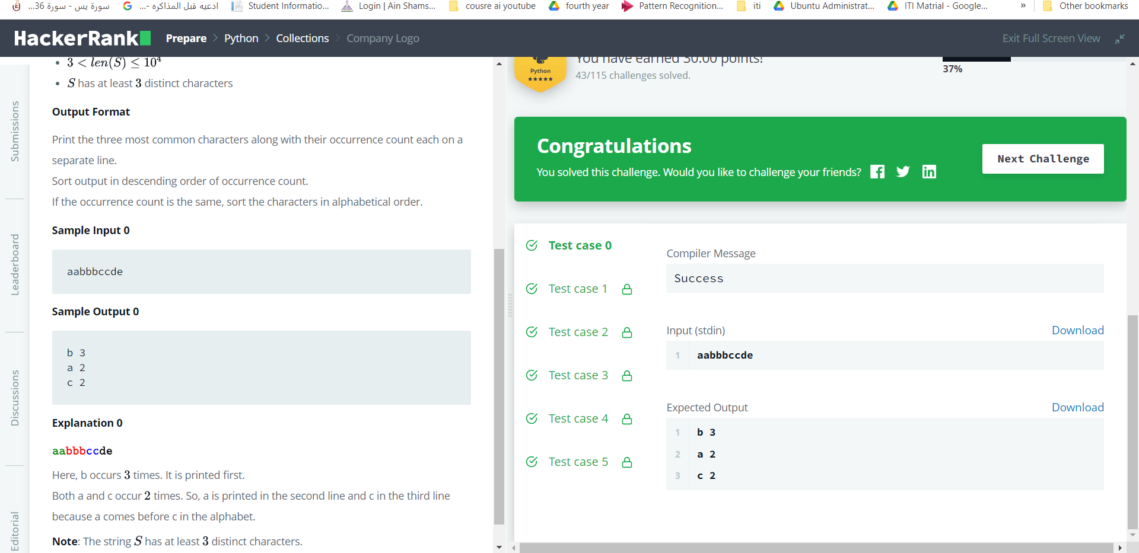

1. Set .union() Operation

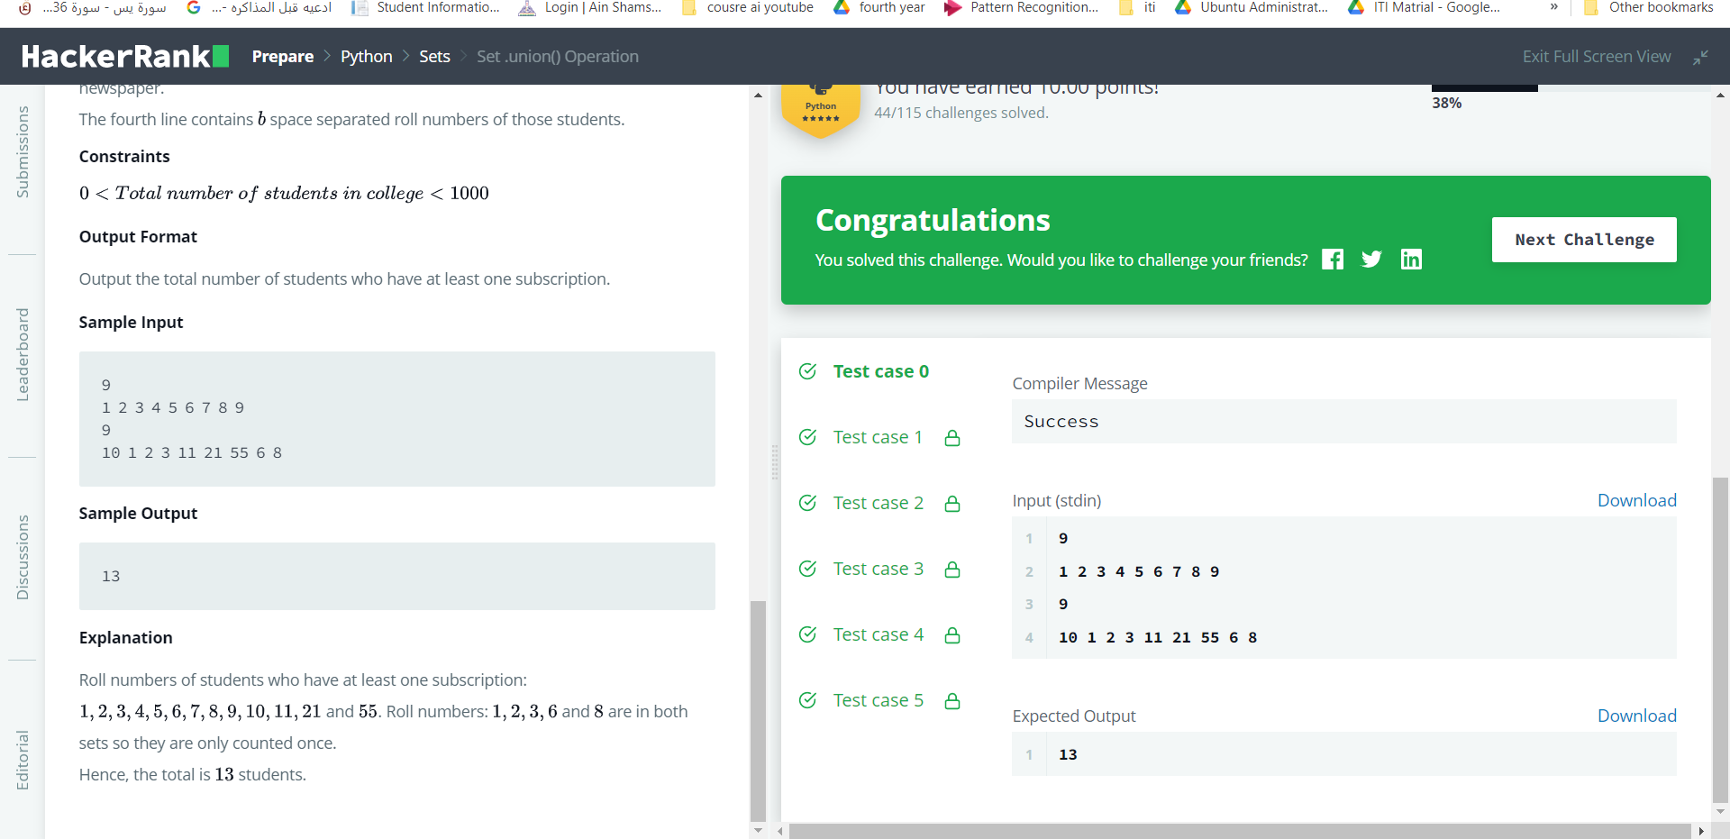

1. Piling Up!
2. Triangle Quest 2

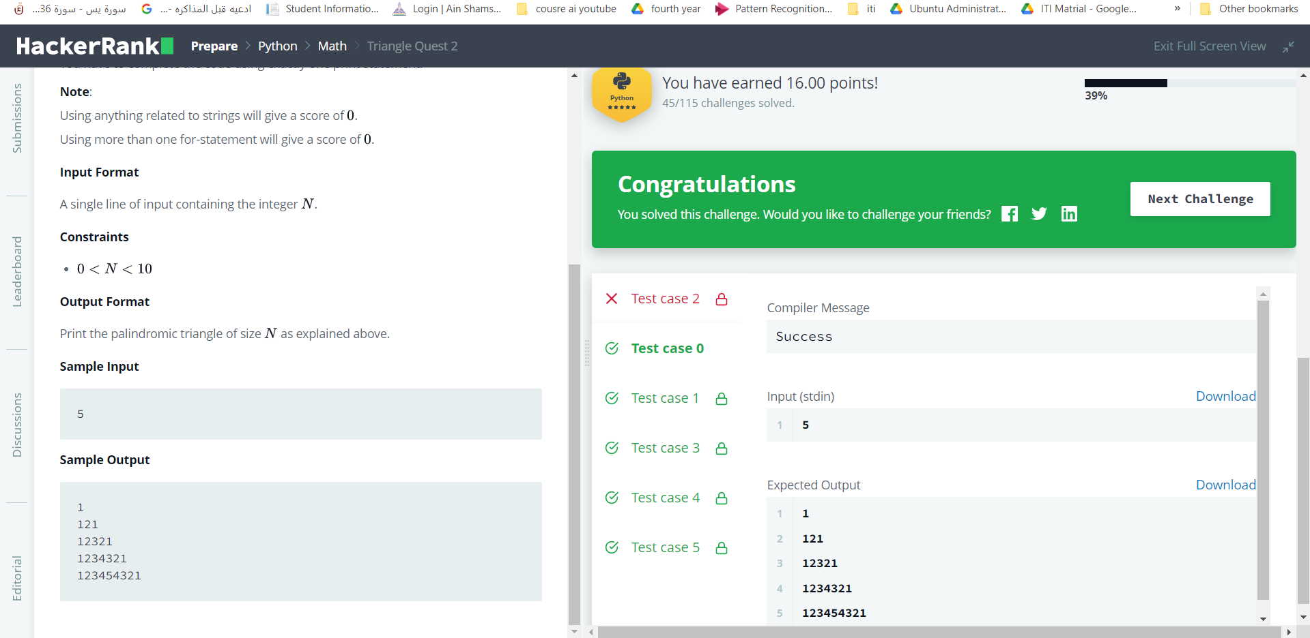

1. Iterables and Iterators
2. Set .intersection() Operation

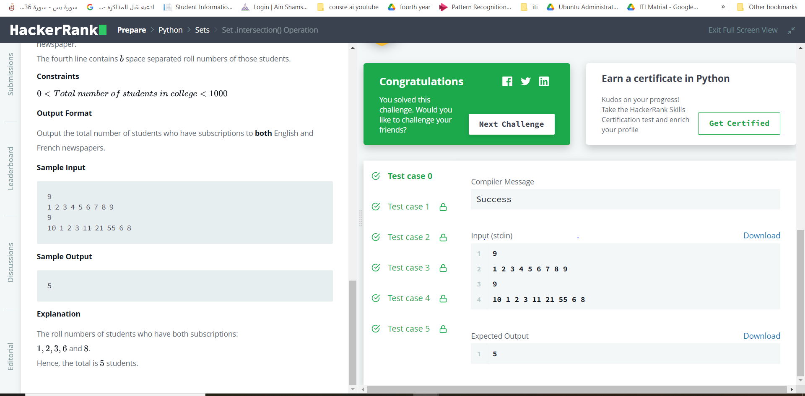

1. Mod Divmod

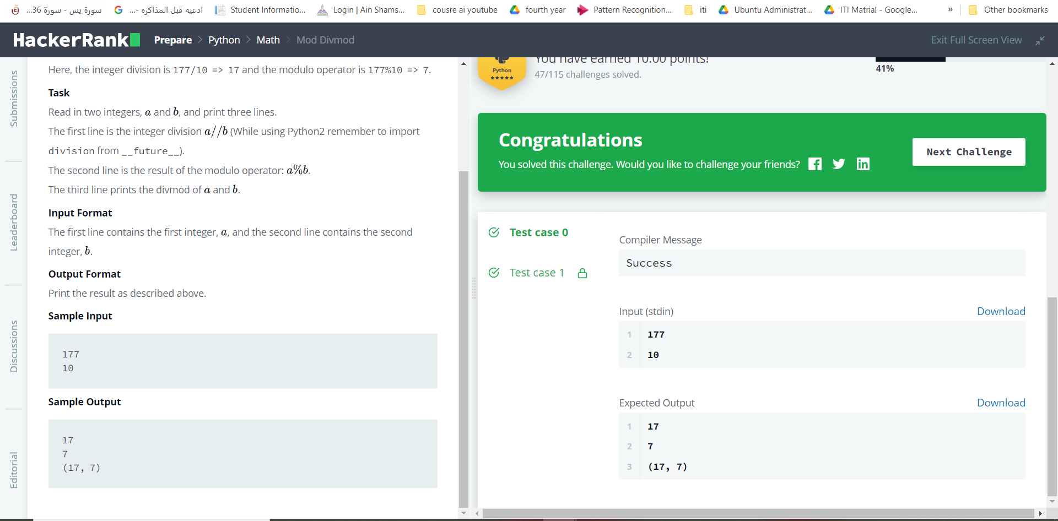

1. Power - Mod Power

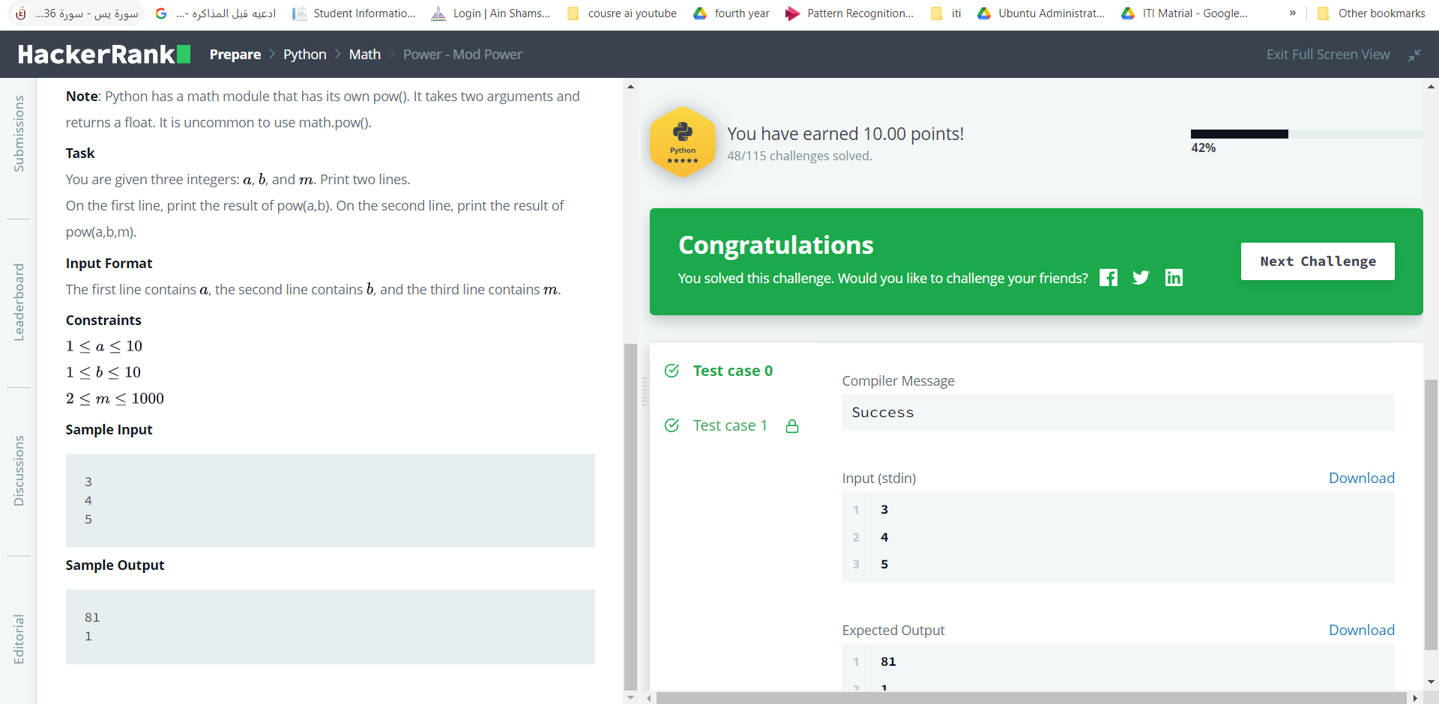

1. Maximize It!

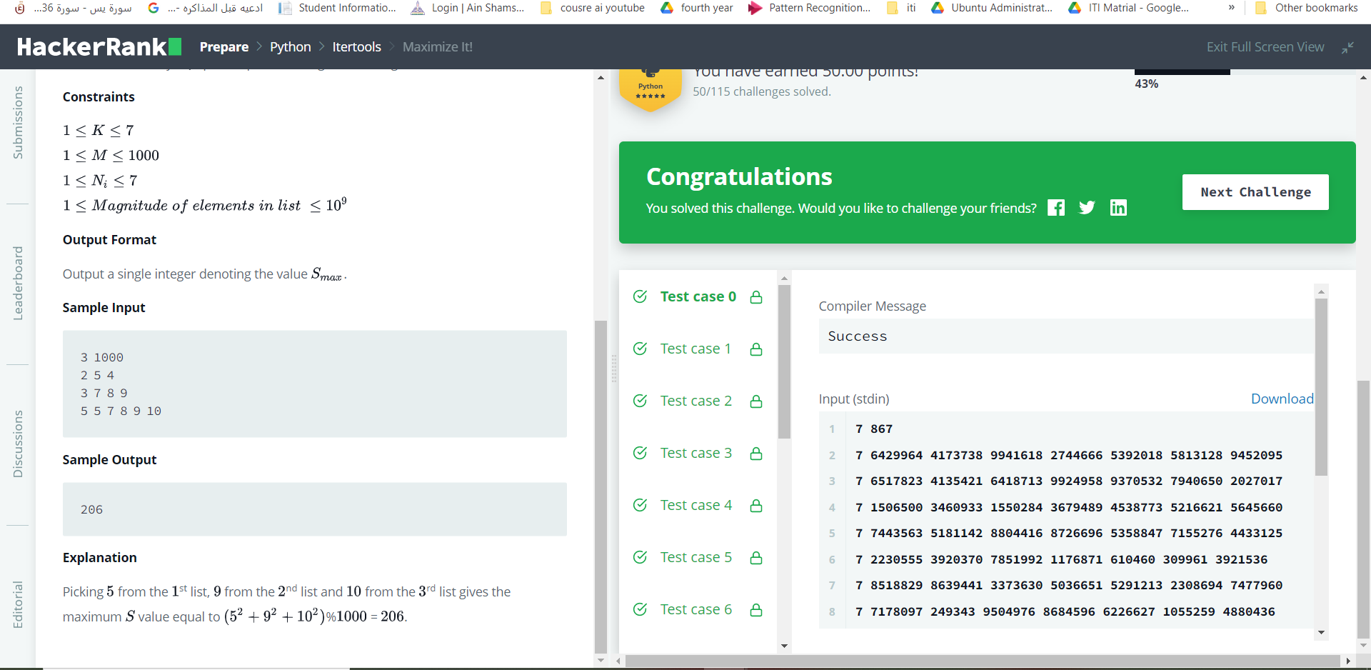

1. Set .difference() Operation

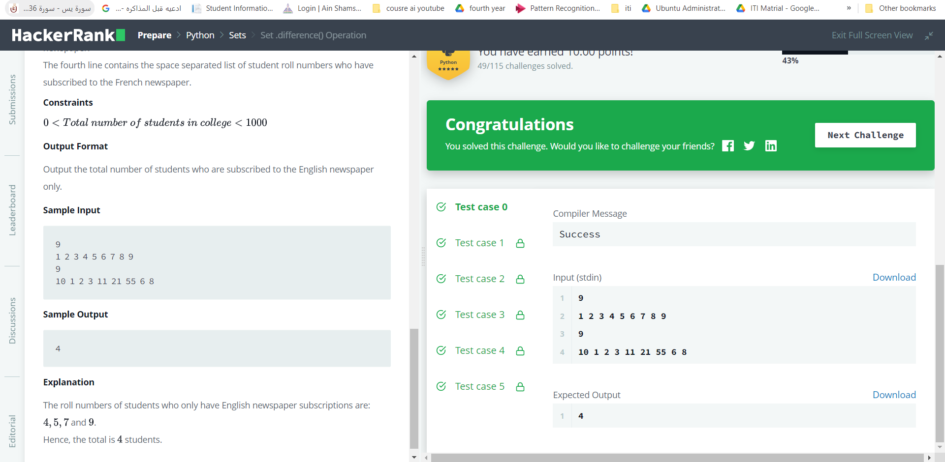

1. Integers Come In All Sizes
2. Set .symmetric_difference() Operation

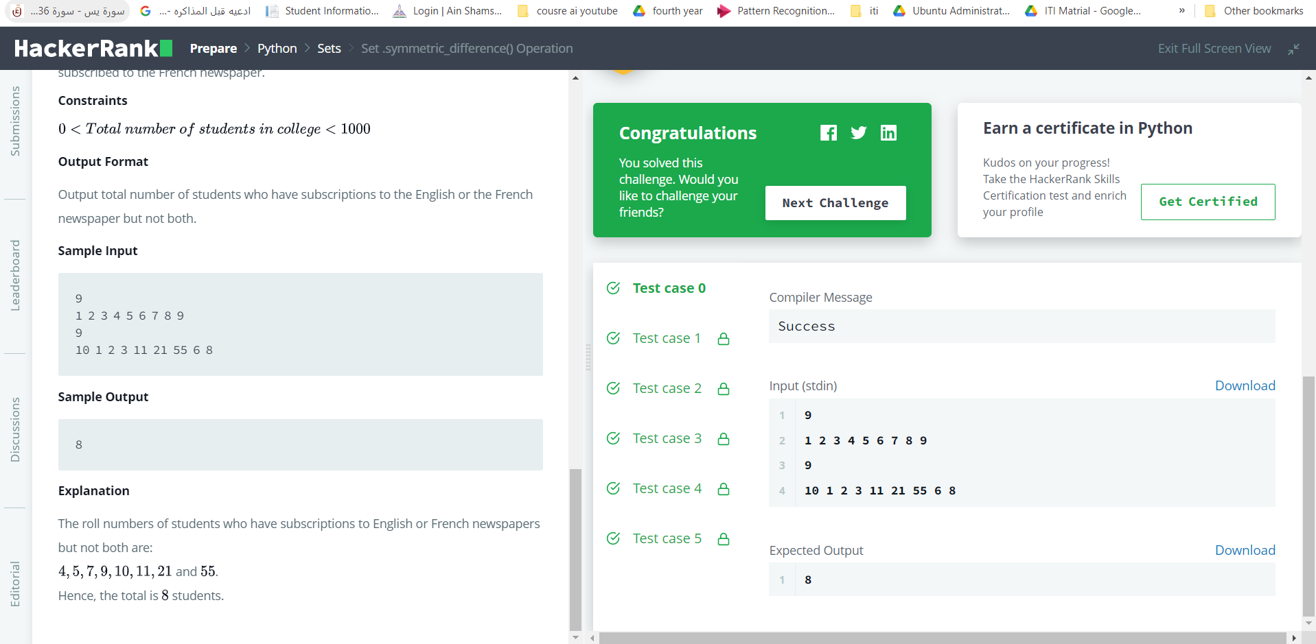

1. Set Mutations

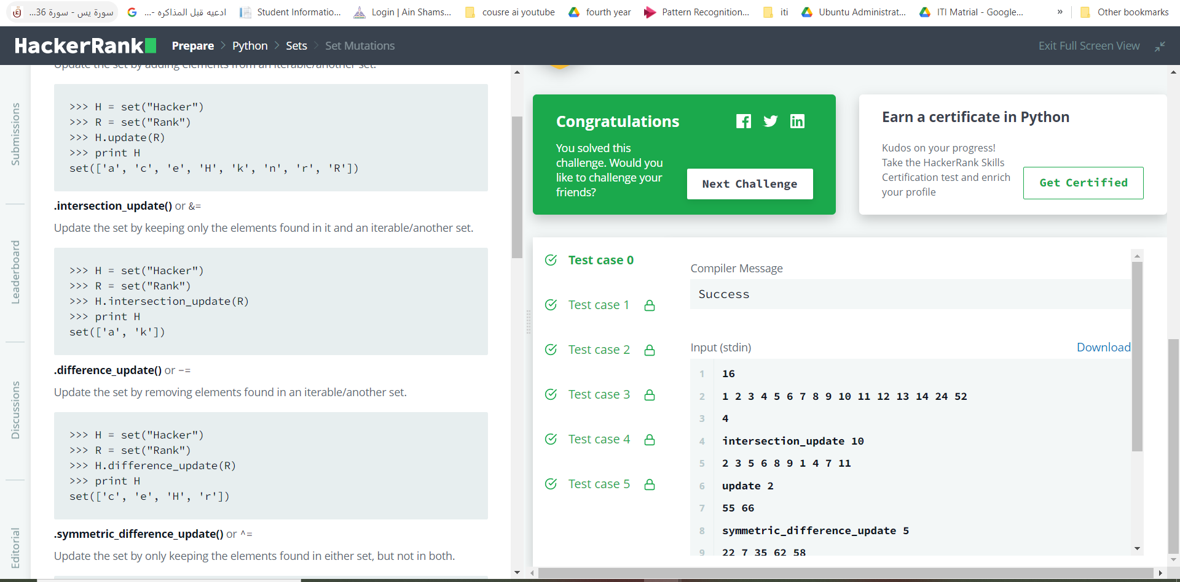

1. Triangle Quest

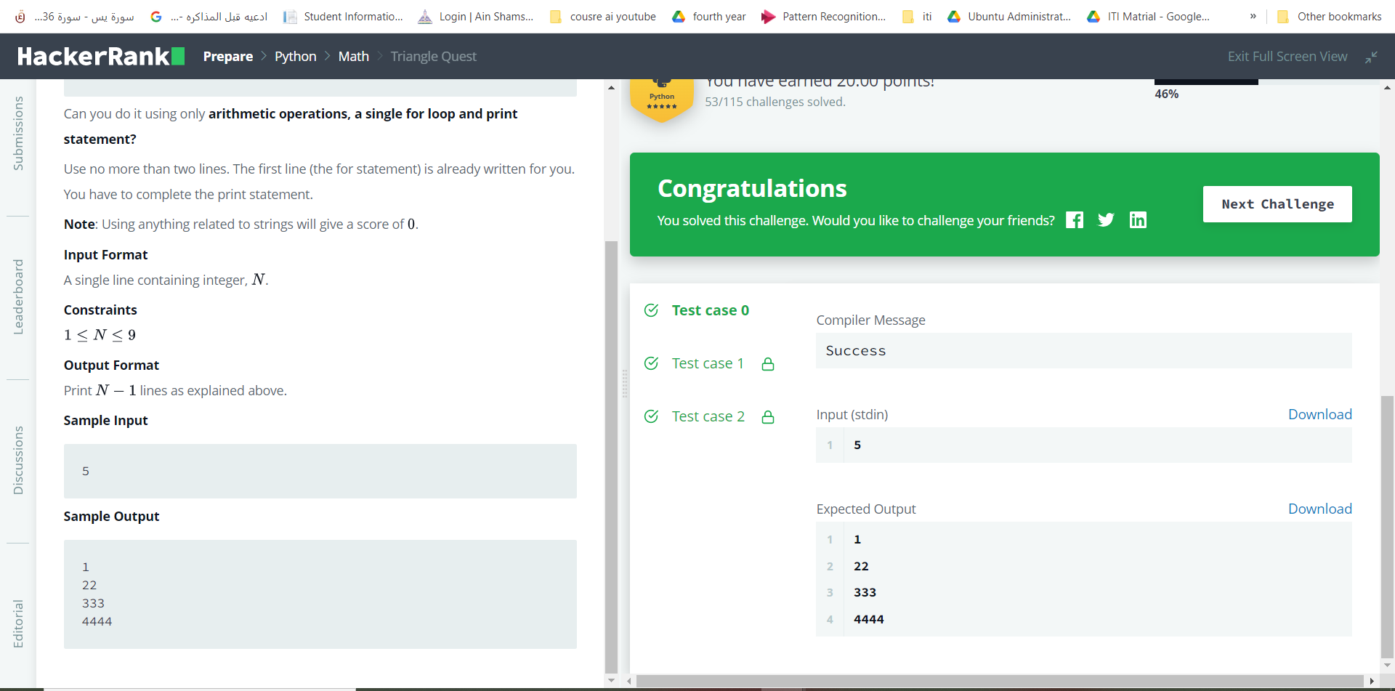

1. The Captain's Room

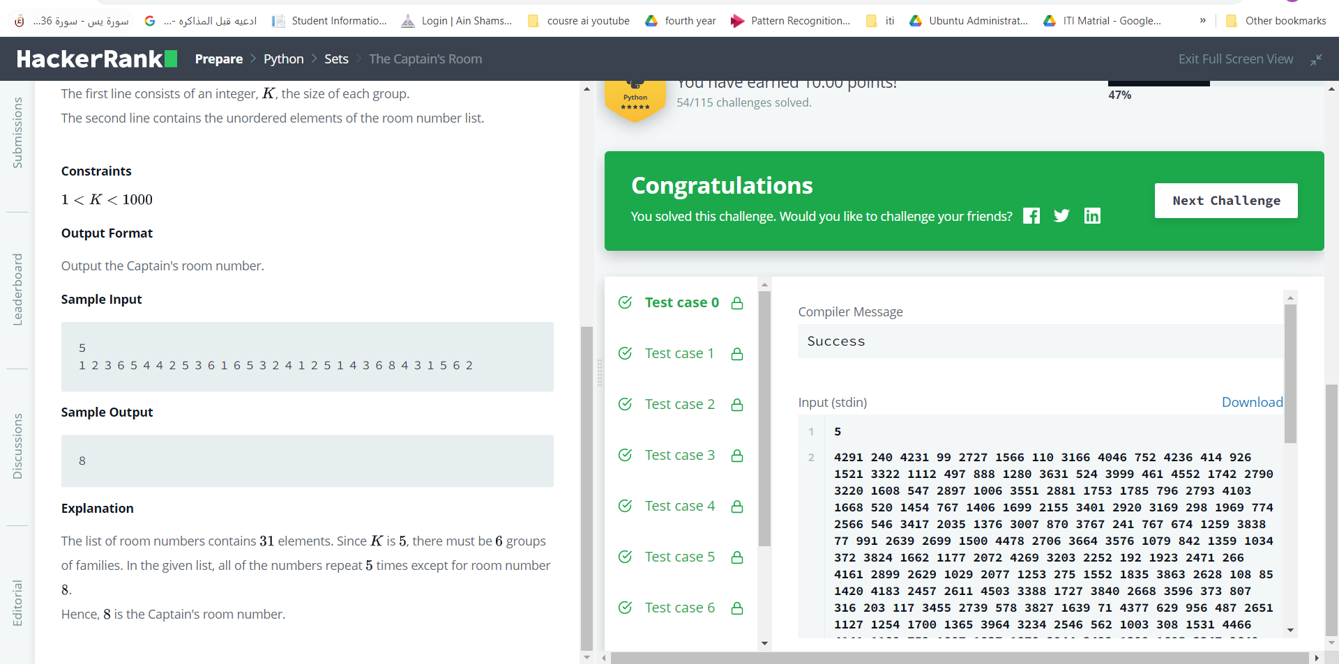

1. Check Subset
2. Check Strict Superset
3. Classes: Dealing with Complex Numbers
4. Class 2 - Find the Torsional Angle
5. Zipped!

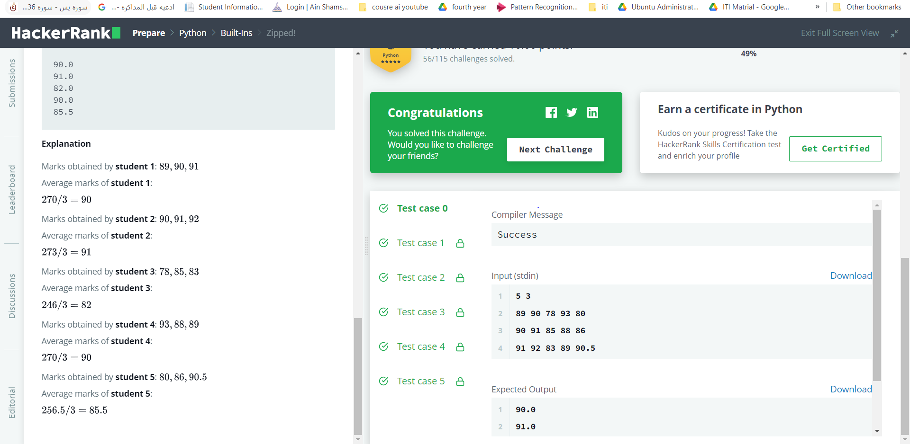

1. Input()

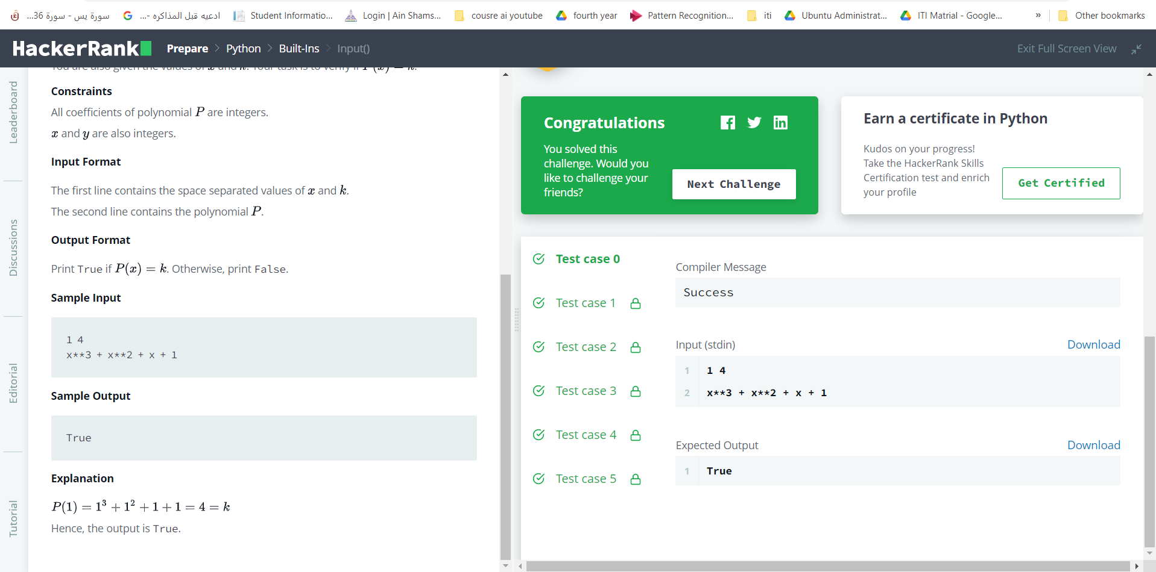

1. Python Evaluation

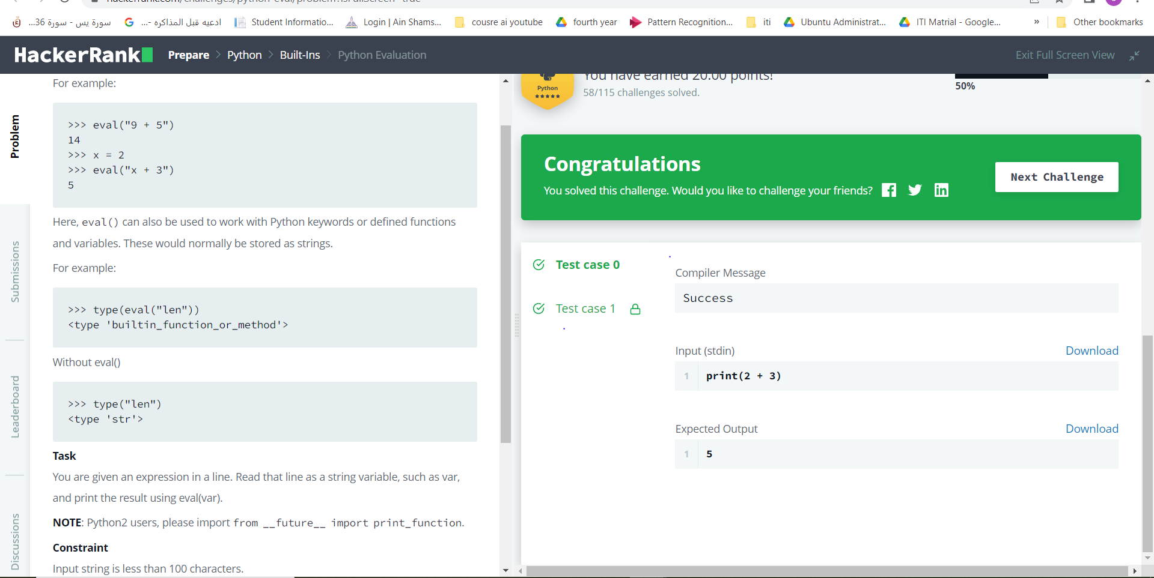

1. Athlete Sort
2. Any or All

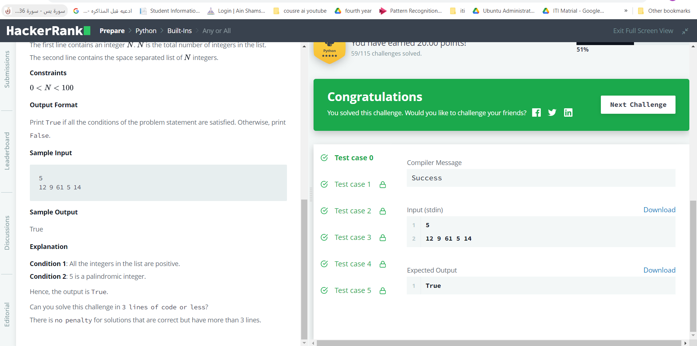

1. ginortS

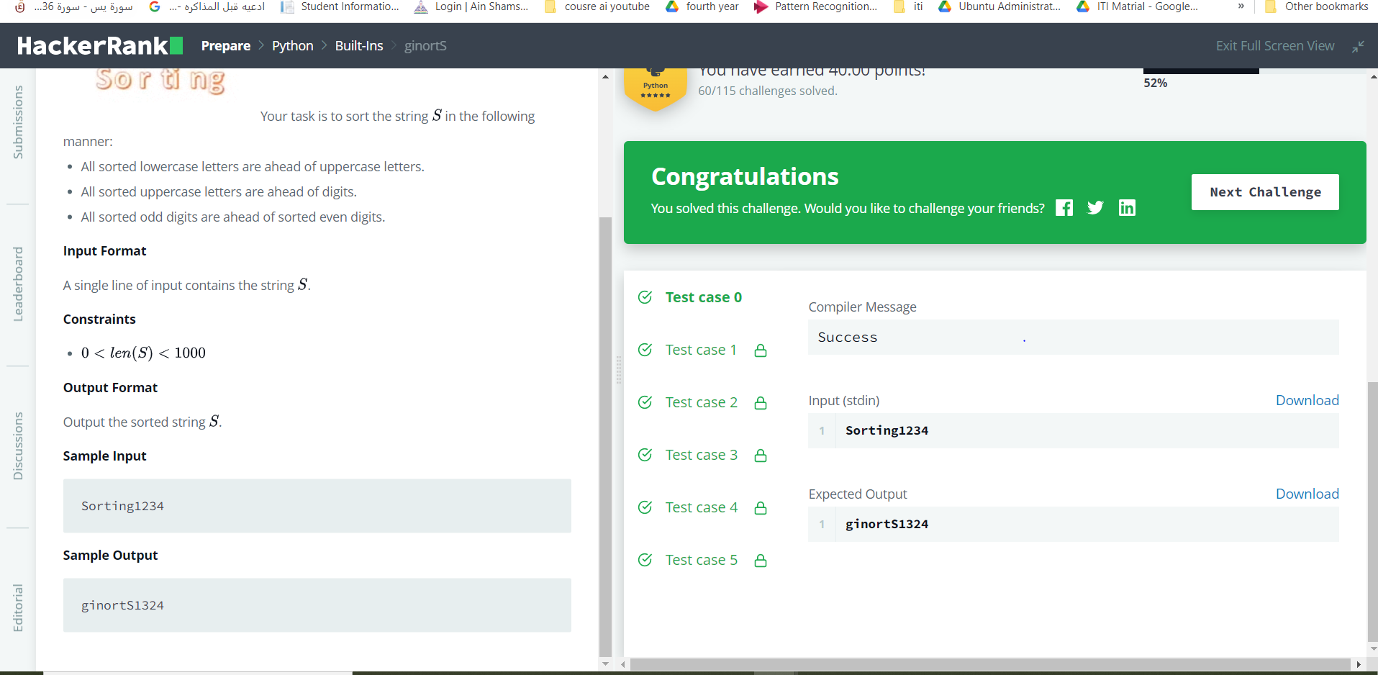

1. Detect Floating Point Number

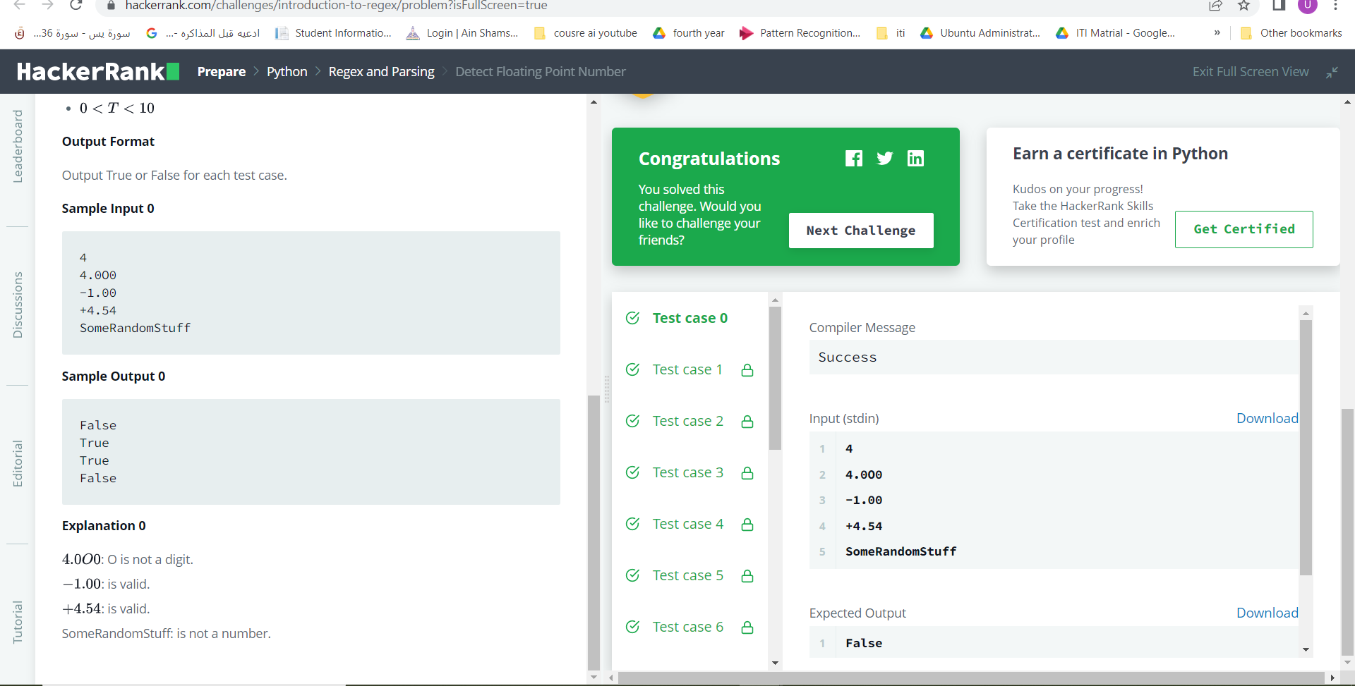

1. Map and Lambda Function
2. Re.split()

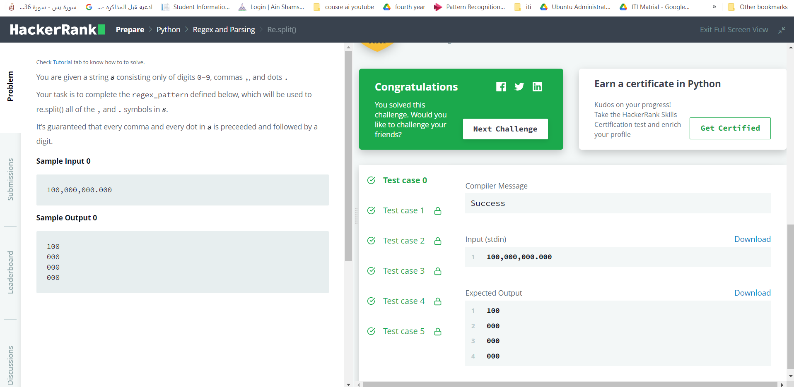

1. Validating Email Addresses With a Filter

